The Coldest Place on Earth  CHAPTER ONE  Two Ships  The race began in the summer of 1910.  On June 1st, in London, a black ship, the Terra Nova, went down the river Thames to the sea. Thousands of people stood by the river to watch it. They were all excited and happy.  On the Terra Nova, Captain Robert Falcon Scott smiled quietly. It was a very important day for him. He was a strong man, not very tall, in the blue clothes of a captain. He was forty-one years old, but he had a young face, like a boy. His eyes were dark and quiet.  One man on the ship, Titus Oates, smiled at Scott.  'What an exciting day, Captain!' he said. 'Look at those people! I feel like an important man!'  Scott laughed. 'You are important, Titus,' he said. 'And you're going to be famous, too. We all are. Do you see this flag?' He looked at the big British flag at the back of the ship, and smiled at Oates. 'That flag is coming with us,' he said. 'In the Antarctic, I'm going to carry it under my clothes. We're going to be the first men at the South Pole, and that flag is going to be first, too!'  Five days later, on June 6th, a man opened the door of his wooden house in Norway. He was a tall man, with a long face.  He waited outside the house for a minute. Everything was very quiet. He could see no houses, only mountains, trees, and water. It was nearly dark. The sky was black over the mountains.  The man smiled, and walked quickly away from the house, down to the sea. In the water, a big wooden ship waited for him. The man got onto the ship, and talked and laughed quietly with his friends.  The ship's name was the Fram, and the man was Roald Amundsen. 'The Fram was the most beautiful ship on earth,' Amundsen thought. His friends were the best skiers on earth, too. One of them, Olav Bjaaland, smiled at him.  'North Pole, here we come, Captain,' he said.  'Yes.' Amundsen said. His friends could not see his face in the dark. 'Fram is going to the Arctic.'  Everyone on the Fram was ready to go to the North Pole, to the Arctic. Amundsen wanted to go there, too. But first he wanted to go south. His friends didn't know that.  At midnight on June 6th, the Fram moved quietly away from Amundsen's house, out to sea.  1  'We have to go a long way south before we get to Alaska,' he said. 'Very near Antarctica, you know. And Captain Scott, the Englishman, is going to the South Pole this year. He wants to put his British flag there. An American flag at the North Pole, a British flag at the South Pole.'  Bjaaland began to understand. He started to smile and couldn't stop. He was warm and excited.  'Well, boys,' Amundsen said slowly. 'Do we want the British to put their flag at the South Pole first? How fast can we travel? We have a lot of dogs, and some of the most wonderful skiers on earth - Bjaaland here is the best in Norway! So I have an idea, boys. Let's go to the South Pole, and put the Norwegian flag there before the British! What do you say?'  For a minute or two it was very quiet. Amundsen waited, and the men watched him and thought. Then Bjaaland laughed.  'Yes!' he said. 'Why not? It's a ski race, isn't it, and the English can't ski! It's a wonderful idea, of course! Let's go!'  CHAPTER THREE  The Ponies  On October 27th, the Terra Nova arrived in Wellington, New Zealand. When Scott came off the ship, a newspaper man walked up to him.  'Captain Scott! Captain Scott! Can I talk to you, please!' he said.  Scott stopped and smiled. 'Yes, of course,' he said. 'What do you want to know?'  'Are you going to win?' the man asked. 'Win?' Scott asked. 'Win what?'  'Win the race to the South Pole, of course,' the newspaper man said. 'It's a race between you and Amundsen, now. Look at this!' He gave a newspaper to Scott. Scott looked at it. It said:  The Fram races Scott to South Pole  'We're going to win!' says Amundsen  Scott's face went white. 'Give me that!' he said. He took the newspaper and read it carefully. The newspaper man watched him, and waited. 'Well, Captain Scott,' he said at last. 'Who's going to win this race? Tell me that!'  Scott looked at him angrily. 'This is stupid!' he said. 'It's not a race! I came here to learn about the Antarctic - I'm not interested in Amundsen, or in races!' Then he walked back onto his ship, with the newspaper in his hand.  Later that day, he talked to his men. He gave them the newspaper, and laughed.  'It doesn't matter,' he said. 'We're in front of Amundsen, and we have more men, and more money. He has only eight men, and a lot of dogs. I know about dogs - they don't work in the Antarctic. We have sixteen men and the new motor sledges - they are much better. And tomorrow the ponies are coming.  3  It was easy. The weather was warm for the Antarctic, between -7° Centigrade and -17° Centigrade. The snow was good, and the dogs and skis went fast. They went fifty or sixty kilometres every day. After four days they reached 80° South, and made the first depot.  Amundsen made his depot very carefully. It was very important to find it again, next summer. So he put a big black flag on top. Then he put ten flags to the east of the depot-each flag half a kilometre from the next - and ten flags to the west. So there were flags for five kilometres to the left of the depot, and five kilometres to the right.  Then they went back to Framheim, and took some more food south, this time to 82° South.  This time it was harder. The temperature was sometimes -40° Centigrade, and there were strong winds with a lot of snow. The dogs and men were very tired, and the tents and boots were bad. At the second depot, they put out sixty flags, to help them find it again.  They came back to Framheim on March 23rd. It was nearly winter in the Antarctic. Their ship Fram was far away now, near South America. They were alone on the ice.  ***  Oates went with Scott to make the first British depot. They left Cape Evans on January 25th. There were thirteen men, eight ponies, and twenty-six dogs. The dogs were faster than the ponies - they ran quickly over the top of the snow, but the ponies' feet went through it. Every morning the ponies started first, and the dogs started two hours later, because they ran faster. At night, the dogs made warm holes under the snow, but the ponies stood on top of the snow. It was -20° Centigrade.  After fifteen days Oates talked to Scott. There was a strong wind, and the two men's faces were white with snow.  'Three of these ponies are ill, Captain,' Oates said. 'They can't go on.'  'Don't be stupid, Oates,' Scott answered. 'They're good strong animals - the best ponies on earth.'  'Not these three,' Oates said. 'They're ill, and unhappy, and now they can't walk. Let's kill them, and leave the meat here, in the snow. We can eat it, or the dogs can.'  'Of course not!' Scott said angrily. 'These ponies are our friends; they work hard for us. I don't kill my friends!'  Three days later, two of the ponies were dead.  Scott's men were slower than Amundsen's; it took them twenty-four days to get to 80° South. They made a big depot there, and put one large black flag on top of it. Then they went back to Cape Evans. 5  In Scott's camp, at Cape Evans, no one talked about Amundsen and no one worked hard. They had good food, and they played football on the snow. They wrote a newspaper - The South Polar Times - and read books. No one learnt to ski, no one worked on the motor sledges. Twice, men went for long journeys across the snow. They walked, and pulled the sledges themselves. Oates stayed at Cape Evans and looked after his ponies.  Over the window in Cape Evans, Scott put a map of Antarctica. With a pen, he made a line from Cape Evans to the South Pole, and he put a little British Flag at the Pole. Under the map, Scott wrote the day for the start of their journey.  We start on November 3rd, he wrote.  CHAPTER SIX  A Bad Start  On August 23rd, the Norwegians' sledges were ready. They took them outside, and the dogs pulled them across the ice. The sun came up for a half an hour, but it was too cold: -46° Centigrade. They could not travel in that weather. They went back to Framheim and waited.  They waited two weeks, until September 8th. Then, with the temperature at -37° Centigrade, they started. They ran happily across the snow to the south - eight men, seven sledges, and eighty-six dogs. Only Lindstrem, the cook, stayed behind in Framheim.  At first everything went well. They went twenty-eight kilometres on Saturday, and twenty- eight kilometres on Sunday. It was easy.  Then, on Monday, the temperature went down - to -56° Centigrade. There was white fog in front of their faces. They couldn't see anything. But they travelled twenty-eight kilometres.  That night, in their tents, they nearly died of cold. Next day, they stopped and made snow houses. Inside the snow houses, it was warm. But everyone was unhappy.  'I told you, Roald!' Johansen said. 'Even September is too early! We can't travel in this cold. Do you want us to die? Let's go back and wait for better weather.'  Amundsen was very angry. He was angry with Johansen, but he was angry with himself, too. He knew Johansen was right.  'All right,' he said slowly. 'We can go on to the depot at 80° South, leave the food there, and then go back. We can't do more than that.'  It was thirty-seven kilometres to the depot. The wind was in their faces all day. Two dogs died on the way. At the depot, they did not stop. They put out the food and the flags, turned round, and went north.  At last the wind was behind them. The dogs ran quickly, and the men sat on the empty sledges. They went faster and faster. It was like a race.  7  There was a lot of wind and fog. On the first day, Wisting's sledge suddenly stopped, and the back went down. 'Come on, you dogs!' he said angrily. 'Pull! Pull!' At first nothing happened; then, slowly, the sledge moved again. Wisting looked down, over the side of the sledge. Under the snow, there was a fifty metre hole.  'Did you see that?' Amundsen said. 'The ice wants to eat us - men, dogs, sledges, everything.'  On the fourth day they reached the depot at 80° South. There was a bad snowstorm, but they found the flags easily. Next day the men stayed in their tents, and the dogs played in their holes under the snow. They were all happy. They had a lot of food, they had good equipment, and they were warm. They could travel fast.  Next morning, the snowstorm stopped, and the journey began again. Today, everything is wonderful, Bjaaland wrote in his diary. But where is Scott? In front of us, or behind?  There was no one with the motor sledges; they were broken. Scott looked at them angrily.  'It doesn't matter,' he said. 'Teddy Evans and his men are in front of us. They're good men - they're pulling their sledges themselves. We can get to the Pole on foot.'  Oates looked at Meares. Oates and the ponies were tired, but Meares and his dogs were not. The snow was home for them.  That night, Oates wrote: Three motor sledges at $1,000 each, 19 ponies at $5 each, 32 dogs at $1.50 each. Well, it's not my money, it's Scott's.  On November 21st, one of the ponies died.  ***  On November 11th, the Norwegians saw the mountains.  The mountains were very high - some of the highest on earth. Bjaaland smiled.  'There is good skiing up there, Roald,' he said. 'But can dogs get up there too?'  'Of course they can,' Amundsen said. 'Come on.'  They left Hanssen with the dogs, and skied a little way up the mountains. It was difficult, but the mountains were big and beautiful. Behind the mountains, Amundsen thought there was a high plateau of ice. 'That's it,' Amundsen said. 'That's the road to the Pole. Tomorrow, we can bring the dogs and sledges up here. But now, let's have a ski race. Who can get back to camp first?'  They laughed, and skied happily down the white snow. 'This is like home,' Bjaaland thought. 'But it's bigger than Norway, and better.'  In the next four days, the dogs pulled the sledges eighty-one kilometres, and went up 3,000 metres. At last, Amundsen and Bjaaland stood on the plateau behind the mountains. They were tired, happy men. 9  Teddy Evans was very unhappy. 'Two men, Captain?' he said. 'Why not three?'  'Because Bowers is going to come with me,' Scott said. 'He's strong - we need him.'  'But... you have food on your sledge for four men, not five!' Evans said. 'And Bowers has no skis!'  'I'm the Captain, Teddy!' Scott said. 'You do what I say. Take two men and leave Bowers with me!'  Oates wrote to his mother: I am going to the Pole with Scott, I am pleased and I feel strong. But in his diary he wrote: My feet are very bad. They are always wet now, and they don't look good.  On January 4th Scott's men left Teddy Evans and went on. Scott, Oates, Wilson and Edgar Evans had skis, but Bowers did not. They were 270 kilometres from the Pole.  December 14th 1911 was a warm, sunny day. Five Norwegians skied over the beautiful white snow. It was very quiet. No one spoke. They were excited, and happy.  'Six more kilometres,' Bjaaland thought. Is there a British flag? I can't see a flag, but... '  'Look!' Hassel said. 'What's that over there?'  Bjaaland left his sledge and skied quickly away over the snow. 'What is it?' he thought. 'Is it. . .?No!'  'It's nothing!' he called. 'There's nothing there . . . nothing!'  Three kilometres, two. 'Roald!' Hanssen called to Amundsen. 'Go in front of me, please. It helps my dogs.'  'That's not true,' Bjaaland thought. 'His dogs are running well today. But Hanssen wants Amundsen to be first. The first man at the South Pole!'  They skied on and on, over the beautiful snow.  'Stop!' Amundsen said. He waited quietly for his men. 'This is it,' he said.  Bjaaland looked at him. 'But there's nothing here,' he said.  Amundsen smiled. 'Oh yes there is,' he said. 'There's something very important here, Olav. Very, very important.' 'What's that, Roald?' there, with a Norwegian flag on it.  'Us. We're here now. Isn't that important, Olav?' The four men stood on the snow, and looked at him. Then, slowly, they all began to laugh.  CHAPTER NINE  The End of the Race  The Norwegians stayed two days at the Pole. They left a tent there, with a Norwegian flag on it. Inside the tent, they left some food, a letter for the King of Norway, and a letter for Scott.  11  On March 7th Scott looked at Oates's feet. They were big and black. 'I can't pull the sledge now,' Oates said. 'It's very difficult to walk. Am I going to lose these feet, Captain?'  Scott looked at Oates's feet, and said nothing.  On March 9th they found another depot, but there was not much food. Slowly, they walked on. Oates's feet were worse every day.  March 17th was Oates's birthday. He was thirty-two. He lay in the tent and listened to the wind outside. He was very cold, very hungry, and very very tired.  He wrote a letter to his mother and gave it to Wilson. Then he got up, and opened the door of the tent. He stopped in the door for a minute. Scott, Wilson, and Bowers looked at him. They didn't speak.  'I'm going outside for a minute,' Oates said. 'I may be some time.'  They didn't see him again.  At Cape Evans, the Englishmen waited. On December 11th, Meares and the dogs came back. On January 3rd, Teddy Evans and his two men arrived at Cape Evans. The Terra Nova came, and went. Winter began. Scott did not come.  The Englishmen waited all winter at Cape Evans. Then, on October 26th 1912, they started for the south. Two weeks later, they found a tent. There were three bodies in the tent - Scott, Wilson, and Bowers. They put the bodies under the snow. Then they took the men's letters and diaries, and went north to Cape Evans again.  In Scott's diary they read: Oates died like a good Englishman. We all did. Please, remember us, and look after our families. We did our best.  No one found Oates's body. But he is there, somewhere, under the snow and the wind, in the coldest, emptiest place on earth.  13 - THE END - | CHAPTER TWO  The Race  The Fram went to an island in the south of Norway. It was a very little island, with only one small wooden house, two trees - and nearly a hundred dogs.  'Look at that!' Bjaaland said. 'It's an island of dogs! There are dogs in the water, near the trees, on the house - dogs everywhere!'  Two men came out of the house. 'Hassel! Lindstrem!' Amundsen said. 'It's good to see you! How many dogs do you have for me?'  'Ninety-nine, Roald,' said Hassel. 'The best ninety-nine dogs from Greenland. And they're very happy! They don't work; they just eat and play all day! They're having a wonderful summer here!'  'Good, good.' Amundsen laughed. 'But that's finished now. Hey, Bjaaland! Stop laughing - come down here and help me. Let's get all these dogs onto the ship!'  It was not easy. The dogs were fat and strong, and they didn't want to go on the ship. But at last, after three hours' hard work, all ninety-nine were on the ship, and the Fram went out to sea again.  The men were not happy. The weather was bad, the dogs were dirty, and some of the men were ill. They began to ask questions.  'Why are we bringing dogs with us?' asked one man, Johansen. 'We're going thousands of kilometres south, past Cape Horn, and then north to Alaska. Why not wait, and get dogs in Alaska?'  'Don't ask me,' said his friend, Helmer Hanssen, 'I don't understand it.'  The men talked for a long time. Then, on September 9th, Amundsen called everyone to the back of the ship. He stood quietly and looked at them. Behind him was a big map. It was not a map of the Arctic. It was a map of Antarctica.  Bjaaland looked at Helmer Hanssen, and laughed. Then Amundsen began to speak.  'Boys,' he said. 'I know you are unhappy. You often ask me difficult questions, and I don't answer. Well, I'm going to answer all those questions now, today.  'We began to work for this journey two years ago. Then, we wanted to be the first men at the North Pole. But last year, Peary, an American, found the North Pole. So America was first to the North Pole, not Norway. We're going there, but we're too late.'  'I don't understand this,' Bjaaland thought. 'Why is Amundsen talking about the North Pole, with a map of Antarctica behind him?'  Amundsen stopped for a minute, and looked at all the men slowly. No one said anything.  2  We need ponies, motor sledges, and good strong British men - that's all. Forget about Amundsen! He's not important!'  Scott asked Oates to look after the ponies, but he did not let Oates buy them. When Oates first saw the ponies, in New Zealand, he was very unhappy. Most of the ponies were old, and some of them were ill.  'They're beautiful ponies, Titus,' Scott said. 'They come from China - they're wonderful ponies!'  Oates looked at them angrily, and said nothing. Then he asked: 'Where is their food, Captain?'  'Here!' Scott opened a door.  Oates looked inside. He thought for a minute. 'We need more food than this, Captain Scott! These ponies are going to work in the coldest place on earth - they need a lot of food - more than this!'  Scott smiled quietly. 'We can't take more food on this ship, Titus. Where can we put it? But it doesn't matter, old boy. They're very strong ponies, you know. The best ponies on earth.'  Later that night, Oates wrote a letter to his mother. “ There are nineteen ponies on the Terra Nova now, he wrote. All the ponies are in a small room at the front of the ship. We eat our food in the room under the ponies, so our table is often wet and dirty. Scott makes a lot of mistakes, I think, and Antarctica is a very dangerous place.”  CHAPTER FOUR  Food Depots  The two ships, the Terra Nova and the Fram, arrived in Antarctica, in January 1911, at the end of summer. The Englishmen and the Norwegians wanted to stay on the ice all winter. They wanted to be ready to go to the South Pole at the beginning of the next Antarctic summer.  The dogs pulled the Norwegians' sledges. They ran quickly over the snow and pulled the big sledges from the ship onto the ice. The men ran beside them on skis.  They put a big wooden house on the ice. The house was full of food, and skis, and sledges. They called it Framheim.  Outside the house, the dogs lived in holes under the snow. When the house was ready, the men made their first journey south.  Before the winter, they wanted to take a lot of food south, and leave it in depots. For the long journey to the Pole, they needed a lot of food, and they couldn't carry it all with them. On February 10th, five men, three sledges, eighteen dogs, and half a tonne of food left Framheim and went south.  4  Their camp was on an island in the ice, and the sea ice moved sometimes. There were holes in the ice, and black sea water under it. One day seven ponies went through the ice into the sea, and died. One motor sledge also went into the sea.  CHAPTER FIVE  A Long Cold Winter  It was dark for four months. Outside the wooden house at Framheim, it was often -60° Centigrade. The dogs lived in warm holes under the snow. The men stayed in the house, and worked in their rooms under the snow.  The skis and sledges came from the best shops in Norway, but Bjaaland wasn't happy with them. He changed a lot of things on the skis and sledges. Soon the sledges were stronger than before. The skis were better and faster, too.  All the Norwegians worked hard. They looked after their dogs, and worked on their equipment - the sledges, skis, tents. Every day they thought about their journey to the Pole, and talked about it. And every day, Amundsen thought about Scott. One day, in midwinter, he talked to his men.  'Let's start early, before Scott,' Amundsen said. 'Remember, Scott has more men than us, and he has motor sledges, too. Perhaps they can go faster than us.'  Bjaaland laughed. 'Oh no, they can't go faster than me,' he said. 'On snow, nothing can go faster than a good man on skis.'  'We don't know,' Amundsen said. 'You're the best skier in Norway, but you get tired, and dogs get tired, too. Motor sledges don't get tired. They can go all day and all night.'  Johansen laughed angrily. 'That's stupid,' he said. 'Perhaps the motor sledges can go all night, but the Englishmen can't. The English can't win, Roald - they don't understand snow, but we do. And they're too slow.'  'Perhaps,' Amundsen said. 'But I want to win this race. So we're going to start early! Do you understand?'  It was quiet and warm inside Framheim. Bjaaland looked at Amundsen, and though about the long, cold journey in front of him. He thought about the dogs in their holes under the snow, and listened to the wind over the house. 'When, Roald?' he said quietly.  'On August 24th. The sun comes back on that day. We start then.'  'But we can't!' Johansen said. He looked angry, and unhappy. 'That's too early! We can't start then - it's dangerous and stupid!'  Amundsen looked at Johansen coldly. 'You're wrong, Johansen,' he said. 'We want to win, remember? So we start on August 24th.'  Bjaaland listened to the winter wind outside.  6  Amundsen was on Wisting's sledge, and soon he, Wisting, and Hanssen were three or four kilometres in front. Soon they were alone. They travelled seventy-five kilometres in nine hours, and they reached Framheim at four o'clock that afternoon.  Bjaaland arrived two hours later, with two more men. But the last two - Johansen and Prestrud - went more slowly. Their dogs were tired, their feet were wet and cold, they had no food, and they were alone in the dark. The temperature was -51° Centigrade. They reached Framheim at midnight.  Next morning, Johansen was angry. In front of everyone, he said: 'You were wrong, Roald. September was too early. I told you but you didn't listen. And then you left us alone and we nearly died in the cold! You're a bad captain - I'm a better captain than you are!'  Amundsen was very angry. But at first he said nothing, because he knew that Johansen was right. Then, that evening, he gave a letter to Johansen. It said:  You aren't coming to the Pole with me. When I go south, you can take some dogs and go east to King Edward VII Land. You can go with Prestrud and Stubberud. You can be the first men to go there - but not to the South Pole!  The Norwegians stayed in Framheim and waited. They lay in bed, listened to the wind outside, and thought about Scott and his motor sledges.  CHAPTER SEVEN  Motor Sledges and Mountains  Scott had two motor sledges now. They were the first motor sledges in the Antarctic - the first on earth. On October 24th, the motor sledges started south from Cape Evans. Four men went with them, but Scott stayed at Cape Evans for another week.  Oates was unhappy. He wrote to his mother: We had a very bad winter here. I don't like Scott. We were here all winter, but he didn't learn to ski, or to drive dogs. Our equipment is bad, and he doesn't think about other people. I'm going to sleep in his tent on the journey, but I don't want to.  On November 1st Scott and Oates and six more men left Cape Evans with eight sledges and eight ponies. The ponies walked slowly because their feet went down into the snow. It was hard work for them and they got tired very quickly. They travelled thirteen or fourteen kilometres in a day.  Behind the ponies came Meares with one sledge and some dogs. Meares knew how to drive dogs. Every day, Meares started two hours after the ponies, and arrived two hours before them.  After five days, they found the motor sledges.  The Norwegians began again on October 20th. There were five men this time - Amundsen, Bjaaland, Wisting, Hassel, and Hanssen. They had four sledges, and forty-eight dogs. 8  Bjaaland looked back at the mountains. 'Can a motor sledge get up here?' he asked.  Amundsen smiled. 'No,' he said. 'I don't think so. And Scott doesn't like dogs. So his men are going to pull their sledges up these mountains themselves. Would you like to do that, Olav?'  Bjaaland didn't answer. He smiled, and skied happily away across the snow.  CHAPTER EIGHT  Across the Plateau  On November 21st, the Norwegians killed thirty dogs.  'They were happy,' Amundsen said. 'And now they're going to die quickly. We need three sledges, and eighteen dogs, to go to the Pole.'  When the dogs were dead, the other dogs ate them. The men ate them, too. They were good friends, Bjaaland wrote in his diary. And now they are good food. Two days later, the dogs were fat. Then, in a snowstorm, they began the journey again.  After the snowstorm, there was fog, and in the fog, they got lost on an ice river with hundreds of big holes in it. They could see nothing, and it was very dangerous. In four days they moved nine kilometres. But the ice is beautiful, Bjaaland wrote. Blue and green and white. This is a wonderful place but I don't want to stay a long time.  After the ice, there were strong winds and bad snowstorms. They could see nothing in front of them. But every day, they travelled twenty-five or thirty kilometres. Then, on December 9th, the sun came out. They were at 88° 23' South - 175 kilometres from the Pole.  Five more long days, Bjaaland wrote. That's all now. But where is Scott?  ***  For four days, Scott's men stayed in their tents near the mountains. There is a bad snowstorm outside, Oates wrote. It's too cold for the ponies, and our clothes and skis are bad, too.  On December 9th, Oates killed the ponies. They were tired and ill and they could not walk up to the plateau. Then Meares and his dogs went back to Cape Evans. 'We can pull the sledges ourselves,' Scott said. 'We can do it - we're all strong men.'  There were two sledges and eight men. They went twenty- four kilometres a day. On December 31st, Scott said to Teddy Evans, and the men on the second sledge: 'You can't ski well.  'Leave your skis here.' So they pulled their sledge twenty-four kilometres without skis.  Next day, Scott went to Teddy Evans's tent. 'You are ill, Teddy,' he said. 'You can't come to the Pole. Take two men and go back, tomorrow.' 10  They left some more black flags near the Pole, and one twenty-eight kilometres north. Then they skied away, back to the north.  'It's a beautiful day,' Bjaaland wrote. 'The sun is warm, the snow is good. But the dogs run too quickly – I cannot get in front of them!'  They found their depots easily. There were ten between the Pole and Framheim. Each depot had a lot of food. They laughed and skied quickly down the mountains. Often, they skied fifty kilometres a day. On Friday, January 26th, 1912, they came back to Framheim. It was four o'clock in the morning.  Inside the wooden house, Lindstrem, the cook, was asleep. Amundsen walked quietly to his bed. 'Good morning, Lindstrom,' he said. 'Is our coffee ready?'  The black flags waited at the Pole.  'What's that, Captain?' Bowers said. 'Over there?'  'Where?' Scott asked. 'What - oh my God!'  They all saw the small black flag in the snow, two kilometres in front of them. Slowly, they pulled their sledge to it.  Next day, January 17th 1912, they found the tent and the Norwegian flag. Near it, Scott took the British flag from under his clothes, and put it up. In his diary, Scott wrote: This is a very bad day. We are all tired, and have cold feet and hands. It is -30°  Centigrade and there is a snowstorm. Great God! This is an awful place!  They turned north. Five tired, unhappy men, in the coldest, emptiest place on earth.  On March 13th, 1912, Scott's wife Kathleen, looked at her morning newspaper. NORWAY'S FLAG AT SOUTH POLE, it said. She looked at it for a long time, and then began to cry.  'What's the matter?' her friend asked.  'My poor, poor husband,' Mrs Scott said. 'What's happened to him? Where is he now?'  Scott's men were always hungry. There were not many depots and they were difficult to find. We need to find the next depot today, Oates wrote. But how can we find one black flag in all this snow? It's very difficult. And there is food for four men, not five.  They were all tired and ill, too. Oates's feet were black now, and he could not feel them. On February 16th, Edgar Evans died.  On the 17th they were past the mountains. At the depot there they ate one of the dead ponies. Then they went on - ten, eleven, twelve kilometres a day. They were ill because their clothes were not warm and they didn't have much food. The temperature was sometimes -40° Centigrade.  12  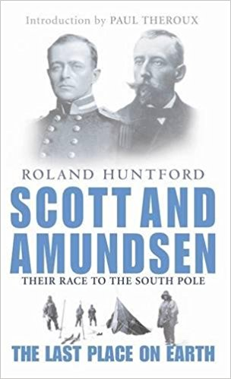

CHAPTER ONE  Two Ships  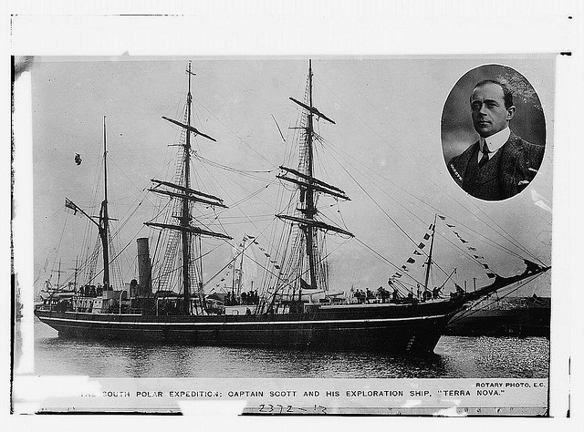 The race began in the summer of 1910.  On June 1st, in London, a black ship, the Terra Nova, went down the river Thames to the sea. Thousands of people stood by the river to watch it. They were all excited and happy.  On the Terra Nova, Captain Robert Falcon Scott smiled quietly. It was a very important day for him. He was a strong man, not very tall, in the blue clothes of a captain. He was forty-one years old, but he had a young face, like a boy. His eyes were dark and quiet.  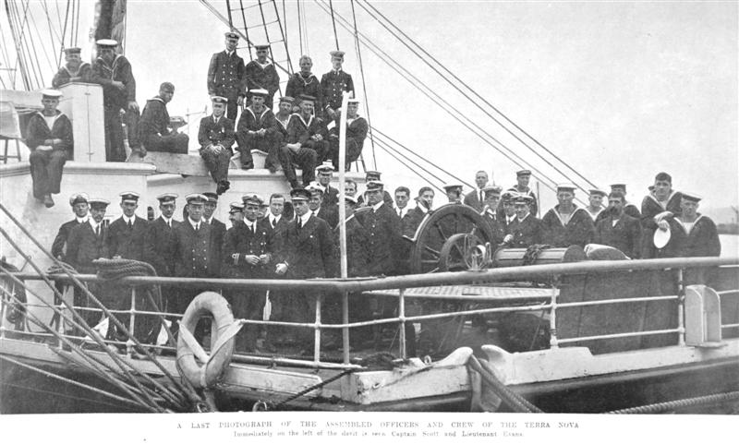 | 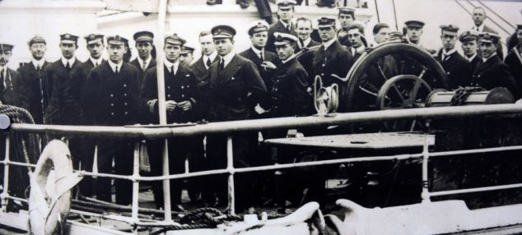  One man on the ship, Titus Oates, smiled at Scott.  ‘What an exciting day, Captain!' he said. 'Look at those people! I feel like an important man!'  Scott laughed. 'You are important, Titus,' he said. 'And you're going to be famous, too. We all are. Do you see this flag?' He looked at the big British flag at the back of the ship, and smiled at Oates. 'That flag is coming with us,' he said. 'In the Antarctic, I'm going to carry it under my clothes. We're going to be the first men at the South Pole, and that flag is going to be first, too!'  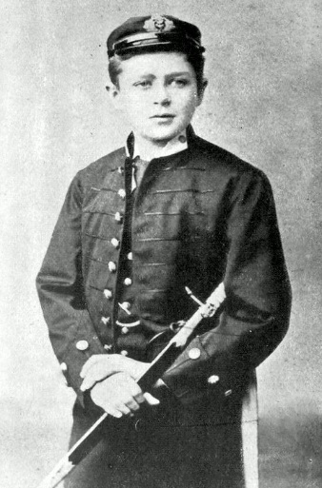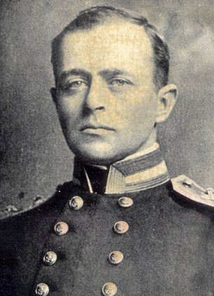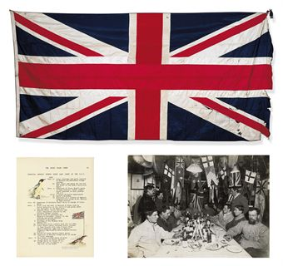

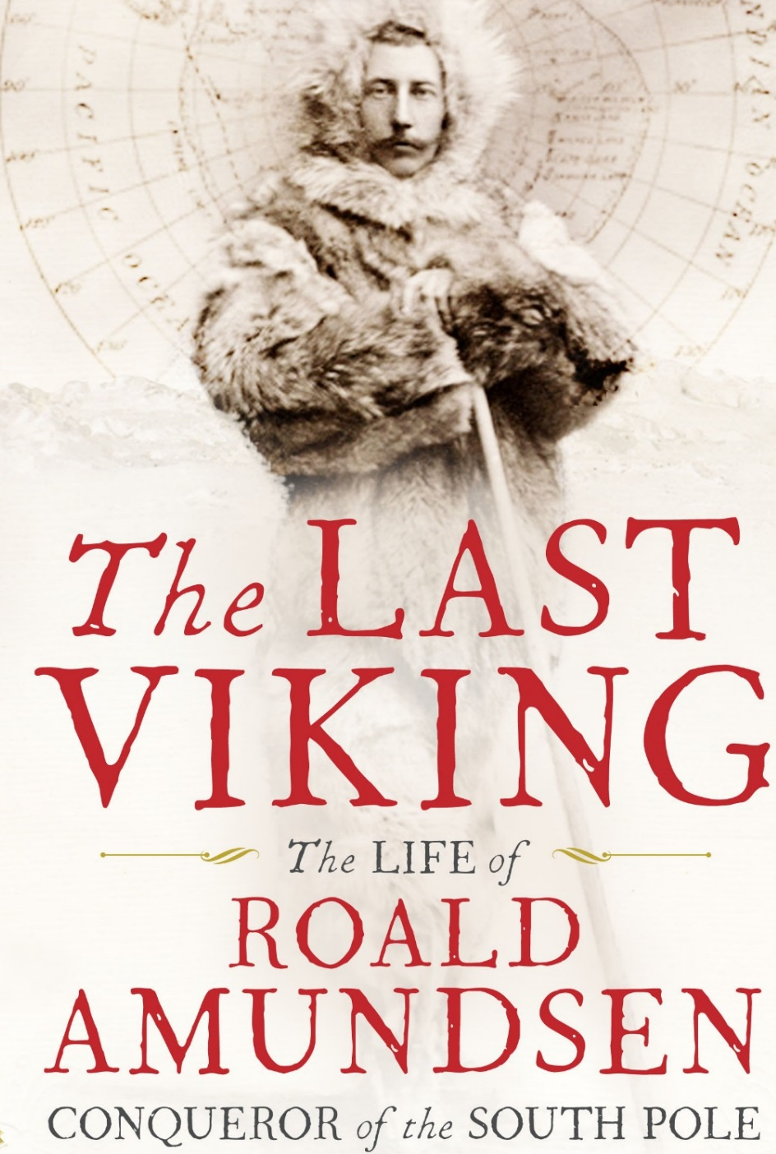 | 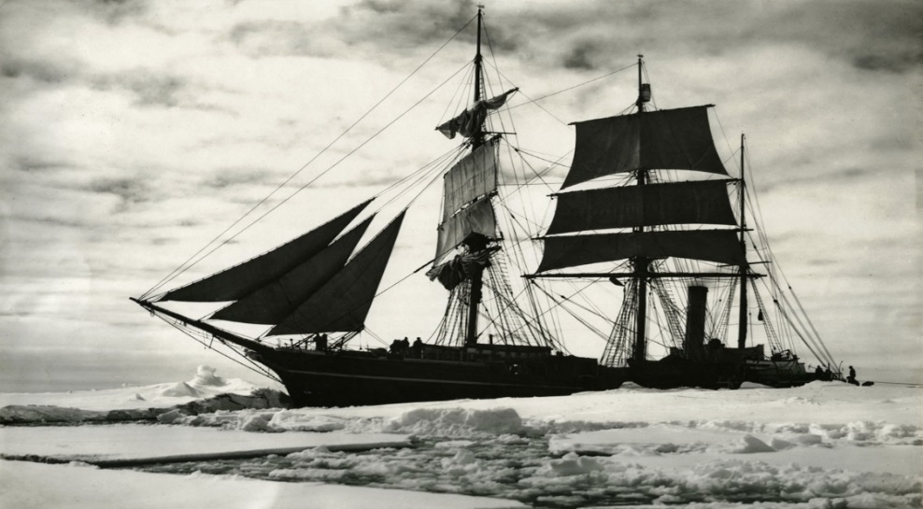  Five days later, on June 6th, a man opened the door of his wooden house in Norway. He was a tall man, with a long face.  He waited outside the house for a minute. Everything was very quiet. He could see no houses, only mountains, trees, and water. It was nearly dark. The sky was black over the mountains.  The man smiled, and walked quickly away from the house, down to the sea. In the water, a big wooden ship waited for him. The man got onto the ship, and talked and laughed quietly with his friends.  The ship's name was Fram, and the man was Roald Amundsen. 'The Fram was the most beautiful ship on earth,' Amundsen thought. His friends were the best skiers on earth, too. One of them, Olav Bjaaland, smiled at him.  'North Pole, here we come, Captain,' he said.  'Yes.' Amundsen said. His friends could not see his face in the dark. 'Fram is going to the Arctic.'  Everyone on the Fram was ready to go to the North Pole, to the Arctic. Amundsen wanted to go there, too. But first he wanted to go south. His friends didn't know that.  At midnight on June 6th, the Fram moved quietly away from Amundsen's house, out to sea.

Chapter One  Two Ships  1.Vocabulary  Race, begin (began), the Terra Nova, be excited, exciting, captain, smile, quietly, important, laugh (laughed), famous, at the back, carry, late - later, wood – wooden, Norway – Norwegian, wait, for a minute, near – nearly, get (got) onto the ship, beautiful, on Earth,  think (thought), skis – skiers, the North Pole, the South Pole,  the Arctic, the Antarctic, everyone, ready, at midnight, out to sea.  2.Answer the Questions:  1)Why were there a lot of people by the River Thames on June 1st?  2)What was the name of the ship? Who was the captain?  3)Why were the people on the ship excited?  4)Where were the people on the ship going?  5)What were they going to do?  6)What did a tall man in Norway do? What did he see?  7)Who was the Norwegian? What was the name of his ship?  8)What did Amundsen think about his ship and about his men?  9)Where did his men think they were going?  10)What was Amundsen’s secret?  3.Insert the Missing Words:  1)Thousands of ________ stood by the river to watch it.  2) He was forty-one years old, but he had a ______ face.  3)’What an _________________ day, Captain!’ he said.  4)I feel like an ______________________ man!  5)You are going to be ________________, too.  6)I’m going to ______________ this flag under my clothes.  7)We’re going to be the _____________ men at the South Pole.  8)A man opened the door of his ____________ house in Norway.  9)In the water, a big wooden ship _____________ for him.  10)His friends were the best __________ on earth, too.  11)His friends couldn’t see his __________ in the dark. | 4.Insert the Prepositions: on, in, under, by, outside, from, of, for, a, away, with, onto, over, down:  1)The race began ____ the summer _____ 1910.  2)Thousands ______ people stood _____ the river to watch it.  3)One man ___ the ship, Titus Oates, smiled __ Scott.  4)He looked ___ the big British flag ___ the back _____ the ship.  5)’The flag is coming ______ us.  6)I’m going to carry it _________ my clothes.  7)Five days later, ___ June 6th, a man opened the door ___ his wooden house ___ Norway.  8)He was a tall man. ___ a long face.  9)He waited ___________ his house ___ a minute.  10)The sky was black _____ the mountains.  11)The man smiled and walked quickly _____ from the house, _______ to the sea.  12)The man got ____ the ship, and talked and laughed quietly ______ his friends.  13)The Fram was the most beautiful ship _____earth.  14)His friends couldn’t see his face ____ the dark.  5.SPEAKING:  1)Captain Robert Scott speaks to Oates about the expedition to the  South Pole.  2)Roald Amundsen is speaking to his men about their voyage .  6.WRITING:  1)Robert Scott is writing in his diary about his plans and intentions.  2)Roald Amundsen is writing in his diary about his plans.  7.EXTENTION:  Find information about the two expeditions to the South Pole by Robert Scott and Roald Amundsen.

CHAPTER TWO  The Race  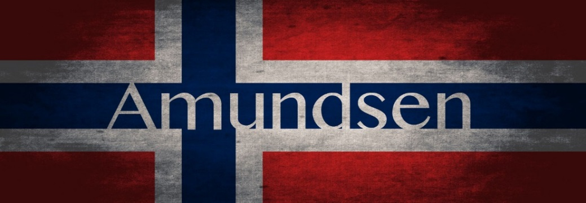  The Fram went to an island in the south of Norway. It was a very little island, with only one small wooden house, two trees - and nearly a hundred dogs.  'Look at that!' Bjaaland said. 'It's an island of dogs! There are dogs in the water, near the trees, on the house - dogs everywhere!'  Two men came out of the house. 'Hassel! Lindstrem!' Amundsen said. 'It's good to see you! How many dogs do you have for me?'  'Ninety-nine, Roald,' said Hassel. 'The best ninety-nine dogs from Greenland. And they're very happy! They don't work; they just eat and play all day! They're having a wonderful summer here!'  'Good, good.' Amundsen laughed. 'But that's finished now. Hey, Bjaaland! Stop laughing - come down here and help me. Let's get all these dogs onto the ship!'  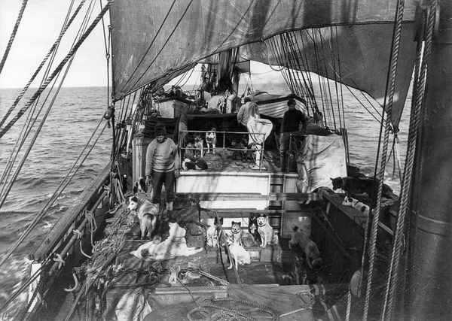  It was not easy. The dogs were fat and strong, and they didn't want to go on the ship. But at last, after three hours' hard work, all ninety-nine were on the ship, and the Fram went out to sea again.  The men were not happy. The weather was bad, the dogs were dirty, and some of the men were ill. They began to ask questions.  'I don't understand this,' Bjaaland thought. 'Why is Amundsen talking about the North Pole, with a map of Antarctica behind him?'  Amundsen stopped for a minute, and looked at all the men slowly. No one said anything.  'We have to go a long way south before we get to Alaska,' he said. 'Very near Antarctica, you know. And Captain Scott, the Englishman, is going to the South Pole this year. He wants to put his British flag there. An American flag at the North Pole, a British flag at the South Pole.'  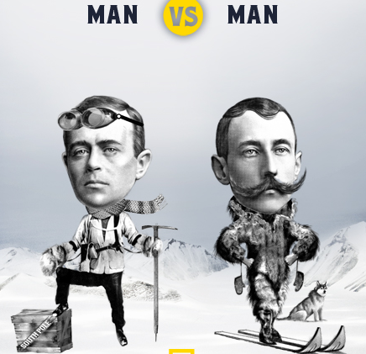  Bjaaland began to understand. He started to smile and couldn't stop. He was warm and excited.  'Well, boys,' Amundsen said slowly. 'Do we want the British to put their flag at the South Pole first? How fast can we travel? We have a lot of dogs, and some of the most wonderful skiers on earth - Bjaaland here is the best in Norway! So I have an idea, boys. Let's go to the South Pole, and put the Norwegian flag there before the British! What do you say?' | 'Why are we bringing dogs with us?' asked one man, Johansen. 'We're going thousands of kilometres south, past Cape Horn, and then north to Alaska. Why not wait, and get dogs in Alaska?'  'Don't ask me,' said his friend, Helmer Hanssen, 'I don't understand it.'  The men talked for a long time. Then, on September 9th, Amundsen called everyone to the back of the ship. He stood quietly and looked at them. Behind him was a big map. It was not a map of the Arctic. It was a map of Antarctica.  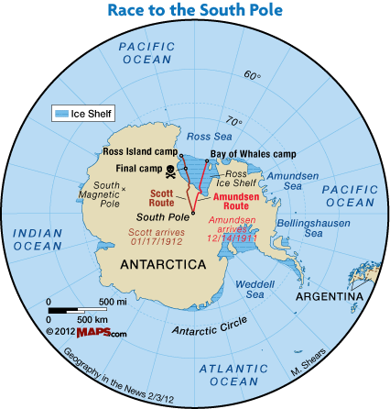  Bjaaland looked at Helmer Hanssen, and laughed. Then Amundsen began to speak.  'Boys,' he said. 'I know you are unhappy. You often ask me difficult questions, and I don't answer. Well, I'm going to answer all those questions now, today.  'We began to work for this journey two years ago. Then, we wanted to be the first men at the North Pole. But last year, Peary, an American, found the North Pole. So America was first to the North Pole, not Norway. We're going there, but we're too late.'  For a minute or two it was very quiet. Amundsen waited, and the men watched him and thought. Then Bjaaland laughed.  'Yes!' he said. 'Why not? It's a ski race, isn't it, and the English can't ski! It's a wonderful idea, of course! Let's go!'  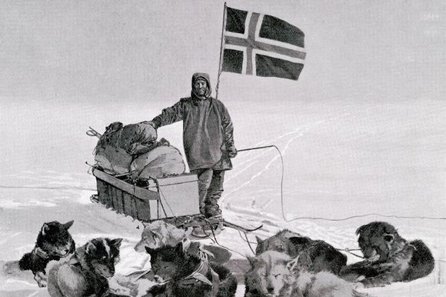  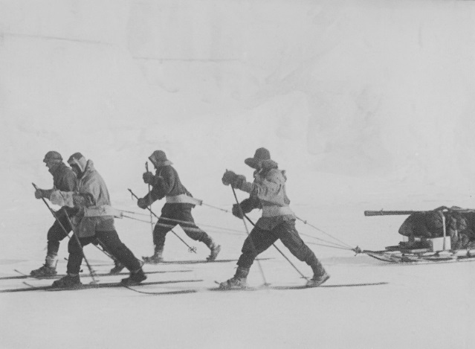
Сhapter Two  The Race  1.Vocabulary:  An island, race, in the South, in the North, in the East, in the West, wait, laugh (laughed), onto, easy, go out to sea, again, weather, dirty, bring (brought), for a long time, quietly, behind, difficult, journey, begin (began), find (found), anything, excited,  2. Answer the Questions:  1)Where did the Fram sail?  2)What did the sailors see on the island?  3)Why wasn’t it easy to get the dogs onto the ship?  4)How long did they work before the Fram went to sea again?  5)Why were the men on the Fram not happy?  6)What questions did the men begin to ask?  7)What map did Amundsen put on the wall behind his back?  8)What was Amundsen’s ambition?  9)Why was Amundsen sure that they could win the race?  3.Finish the Sentences:  a)The Fram went to __ _________ ___ ____ ________ __ ________.  b)It’s an ___________ _____ ________ !  c)Let’s get all these ________ _______ ___ _________.  d)The dogs were fat and ______, ____ _____ ____ ______ ___ ____.  e)”Why are we bringing ________ ______ _____?  f)The men _______ _____ __ ______ _______.  4.Find Opposites to the Words:  south - _____________ near -- ________________  laugh - _____________ easy - _________________  fat - _______________ strong - _______________  dirty - ______________ quiet - ________________  behind - _____________ first - _________________  slowly - ______________ warm - _______________  fast- ______________ best - ________________ | 5.Insert the Missing Words:  1)It’s an island _____ dogs.  2)Two men came ______ ____ the house.  3)How many dogs do you have _____ me?  4)But at last, after three hours’ _______ ______ , all ninety-nine were on the ship, and the Fram went ______ to sea again.  5)The _________ was bad, the _______ were dirty, and some of the ____ were ill.  6)Amundsen _________ everyone to the back of the ship.  7)Behind him was a big ______. It was a _____ of Antarctica.  8)You often ask me __________ questions, and I don’t answer.  9)We began to work for this _______ two years ago.  10)We wanted to be the ______ _______ on the North Pole.  11)Captain Scott, the Englishman, is going to the _____ ______ this year. He wants to ______ his _______ _______ there.  12)We have a lot of _____, and some of the ______ _____ on earth.  13)Let’s go to the _____ ______ and put the Norwegian _______ before the British.  14)Why not! It’s a ski _______, isn’t it, and the English can’t ______!  15)It’s a ____________ idea, of course! Let’s go!  16)For a minute or _____ it was very quiet.  17)Amundsen ________, and the men watched him and _________.  6.SPEAKING:  a)Roald Amundsen is talking to his men about going to the South Pole.  7.WRITING:  Roald Amundsen is writing in his diary about the preparation for the journey and about the situation on board the ship.  8.CULTURAL KNOWLEDGE. Find out about the life and exploits of Roald Amundsen.

CHAPTER THREE  The Ponies  On October 27th, the Terra Nova arrived in Wellington, New Zealand. When Scott came off the ship, a newspaper man walked up to him.  'Captain Scott! Captain Scott! Can I talk to you, please!' he said.  Scott stopped and smiled. 'Yes, of course,' he said. 'What do you want to know?''Are you going to win?' the man asked. 'Win?' Scott asked. 'Win what?'  'Win the race to the South Pole, of course,' the newspaper man said. 'It's a race between you and Amundsen, now. Look at this!' He gave a newspaper to Scott. Scott looked at it. It said:  ‘The Fram races Scott to South Pole. 'We're going to win!' says Amundsen.  Scott's face went white. 'Give me that!' he said. He took the newspaper and read it carefully. The newspaper man watched him, and waited. 'Well, Captain Scott,' he said at last. 'Who's going to win this race? Tell me that!'  Scott looked at him angrily. 'This is stupid!' he said. 'It's not a race! I came here to learn about the Antarctic - I'm not interested in Amundsen, or in races!' Then he walked back onto his ship, with the newspaper in his hand.  Later that day, he talked to his men. He gave them the newspaper, and laughed.  'It doesn't matter,' he said. 'We're in front of Amundsen, and we have more men, and more money. He has only eight men, and a lot of dogs. I know about dogs - they don't work in the Antarctic. We have sixteen men and the new motor sledges - they are much better. And tomorrow the ponies are coming. We need ponies, motor sledges, and good strong British men - that's all. Forget about Amundsen! He's not important!' | Scott asked Oates to look after the ponies, but he did not let Oates buy them. When Oates first saw the ponies, in New Zealand, he was very unhappy. Most of the ponies were old, and some of them were ill. ‘They're beautiful ponies, Titus,' Scott said. 'They come from China - they're wonderful ponies!'  Oates looked at them angrily, and said nothing. Then he asked: 'Where is their food, Captain?'' Here!' Scott opened a door.  Oates looked inside. He thought for a minute. 'We need more food than this, Captain Scott! These ponies are going to work in the coldest place on earth - they need a lot of food - more than this!'  Scott smiled quietly. 'We can't take more food on this ship, Titus. Where can we put it? But it doesn't matter, old boy. They're very strong ponies, you know. The best ponies on earth.'  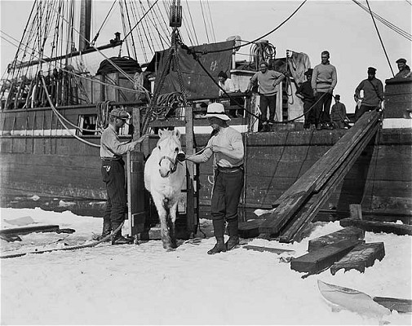  Later that night, Oates wrote a letter to his mother. ‘There are nineteen ponies on the Terra Nova now, he wrote. All the ponies are in a small room at the front of the ship. We eat our food in the room under the ponies, so our table is often wet and dirty. Scott makes a lot of mistakes, I think, and Antarctica is a very dangerous place.’
Chapter Three  The Ponies  1.Vocabulary:  Arrive, a newspaper man, win (won, won), the race, angrily, stupid, to learn about, to be interested in, motor sledges, forget (forgot), important, need, it doesn’t matter, dangerous.  2.Answer the Questions:  1)What did the newspaper man want to hear from Scott?  2)Why was Robert Scott angry with the man?  3)What were Scott’s ambitions?  4)What did Oates think about the ponies?  5)What advice did Oates give to Scott concerning the ponies?  6)What were the conditions like on board the ship?  3.Finish the Sentences:  1)When Scott came off the ship, ……….  2)I came here to learn about ………..  3)”We’re in front of Amundsen, …………  4)We need ponies, …………..  5)Scott asked Oates to look after the……….  6)These ponies are going to work in…………  7)All the ponies are…………  8)Scott makes a lot…………..  4.Give words to the Definitions:  To come to some place ________________  To compete and see who is first _____________  To be the first in a competition ________________  A vehicle that is used in the cold polar areas _______________  A small kind of a horse ____________  Not to be right some times_______________________ | 5.Insert the missing words:  1)On October 27th, the Terra Nova ___________ in Wellington, the capital of Australia. Captain Scott wanted to buy some ___________ for his expedition. When Scott came off the ship, ___________ walked up to him and showed him ____________ about another team that was going to the _________ ________ with Amundsen at its head. The journalist wanted to know who was going to win the _________. Captain Robert Scott was angry – he was not interested in _________. He came to the Antarctic to ________________ about it, and not to race. His team had more _______, and more ______. So, Captain Robert Scott was sure that his men could go to the ________ _________ and put the British flag there. He bought nineteen ___________ from China. When Oates looked at them he saw that most of them were _____, and some of them were _____.  Oates understood that there was not enough ___________ for them. But Captain Scott couldn’t take more __________ on his ship. All the _______ were in a small room in front of the ship, and the men were under the ___________. So, it was often wet and dirty.  6.WRITING.  a) Captain Scott is writing in his diary about the events of the day October, 27th .  b) Titus Oates is writing to his mother about the ponies.  7.SPEAKING.  a) Captain Scott is talking to the newspaper man.  b) Scott is talking to Oates about the ponies.  8.EXTENTIONS: Find out about the life and explorations of Robert Falcon Scott.

CHAPTER FOUR  Food Depots  The two ships, Terra Nova and Fram, arrived in Antarctica, in January 1911, at the end of summer. The Englishmen and the Norwegians wanted to stay on the ice all winter. They wanted to be ready to go to the South Pole at the beginning of the next Antarctic summer.  The dogs pulled the Norwegians' sledges. They ran quickly over the snow and pulled the big sledges from the ship onto the ice. The men ran beside them on skis.  They put a big wooden house on the ice. The house was full of food, and skis, and sledges. They called it Framheim.  Outside the house, the dogs lived in holes under the snow. When the house was ready, the men made their first journey south.  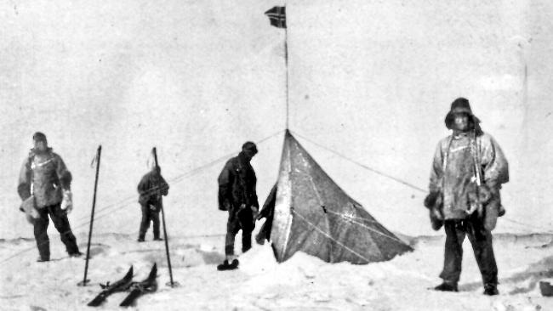  Before the winter, they wanted to take a lot of food south, and leave it in depots. For the long journey to the Pole, they needed a lot of food, and they couldn't carry it all with them. On February 10th, five men, three sledges, eighteen dogs, and half a tonne of food left Framheim and went south.  Oates went with Scott to make the first British depot. They left Cape Evans on January 25th. There were thirteen men, eight ponies, and twenty-six dogs. The dogs were faster than the ponies - they ran quickly over the top of the snow, but the ponies' feet went through it. Every morning the ponies started first, and the dogs started two hours later, because they ran faster. At night, the dogs made warm holes under the snow, but the ponies stood on top of the snow. It was -20° Centigrade.  After fifteen days Oates talked to Scott. There was a strong wind, and the two men's faces were white with snow.  'Three of these ponies are ill, Captain,' Oates said. 'They can't go on.'  'Don't be stupid, Oates,' Scott answered. 'They're good strong animals - the best ponies on earth.'  'Not these three,' Oates said. 'They're ill, and unhappy, and now they can't walk. Let's kill them, and leave the meat here, in the snow. We can eat it, or the dogs can.'  'Of course not!' Scott said angrily. 'These ponies are our friends, they work hard for us. I don't kill my friends!'  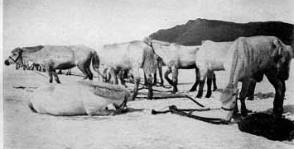  Three days later, two of the ponies were dead.  Scott's men were slower than Amundsen's; it took them twenty-four days to get to 80° South. They made a big depot there, and put one large black flag on top of it. Then they went back to Cape Evans.  Their camp was on an island in the ice, and the sea ice moved sometimes. There were holes in the ice, and black sea water under it. One day seven ponies went through the ice into the sea, and died. One motor sledge also went into the sea. | It was easy. The weather was warm for the Antarctic, between -7° Centigrade and -17° Centigrade. The snow was good, and the dogs and skis went fast. They went fifty or sixty kilometres every day. After four days they reached 80° South, and made the first depot.  Amundsen made his depot very carefully. It was very important to find it again, next summer. So he put a big black flag on top. Then he put ten flags to the east of the depot-each flag half a kilometre from the next - and ten flags to the west. So there were flags for five kilometres to the left of the depot, and five kilometres to the right.  Then they went back to Framheim, and took some more food south, this time to 82° South.  This time it was harder. The temperature was sometimes -40° Centigrade, and there were strong winds with a lot of snow. The dogs and men were very tired, and the tents and boots were bad. At the second depot, they put out sixty flags, to help them find it again.  They came back to Framheim on March 23rd. It was nearly winter in the Antarctic. Their ship Fram was far away now, near South America. They were alone on the ice.  ***  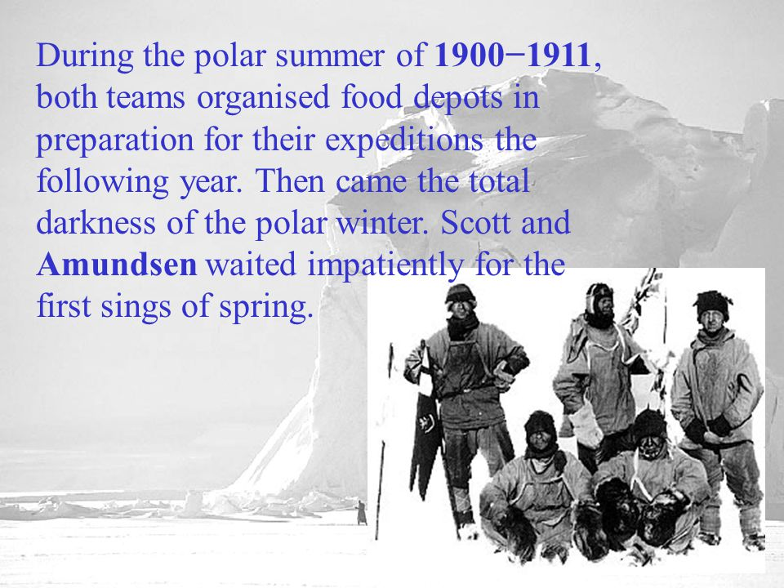  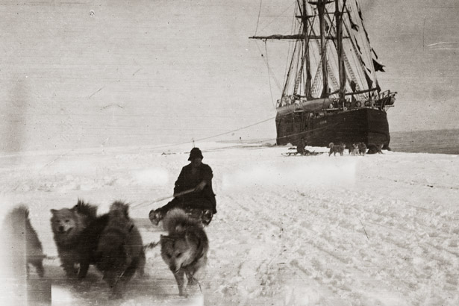  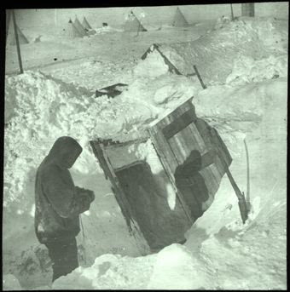
Chapter Four  Food Depots  1.Vocabulary:  Depot, pull, sledges, to run on skis, outside, holes, journey, leave (left, left), need, carry (carried), half a tonne, Centigrade, Celsius, reach, hard – harder, be tired, nearly, far away, alone, preparation, expedition, the following year, the total darkness- the Polar winter, wait impatiently, signs of spring, slow-slower,  2.Answer the Questions:  1)When did the two ships arrive in the Antarctica?  2)What were the both teams planning to do in Antarctic winter?  3)What did the Norwegians build on the ice?  4)What did the Norwegians want to make on their way to the South?  5)Where did they make their first depot?  6)How did they make their depots?  7)How did the Scott’s team move to the South?  8)Why didn’t Scott want to kill the ponies?  8)What happened to the ponies and the moto sledge?  3.Give a Words to the Definition:  500 kilogrammes _______________  To go from the place _______________  To go to some place _______________  To be not near _______________  Next year __________________  A store __________________  A journey ________________  Getting ready ___________________  Cannot wait until ________________  Almost ______________ | 4.Find the Opposites:  to stay - ______________ to drop - _______________  light - ________________ to push - _______________  easy - ________________ fast - __________________  together - ____________ very close - _____________  5.Insert the Missing Words:  1)The Englishmen and the Norwegians wanted to _______ on the ice all __________.  2)The dogs ____________ the big sledges from the ship onto the ice.  3)They put a big _________ ______ on the ice.  4)When the house was ready, the men made their first _____ south.  5)Before the ______ they wanted to take a lot of food _______, and leave it in ____________.  6)The ______ was good, and the ______ and _____ went fast.  7)They went _____ or _____ kilometres every day.  8)Then they went _____ to Framheim, and took some more _____ south, this time to 82⁰ ________.  9)Oates went with Scott to make the first British _______.  10)The ______ were faster than ________.  11)At night the dogs made warm ______ under the snow.  6.SPEAKING:  a)Amundsen speaks how he made his depots.  b)Scott speaks how he made his depots.  7.WRITING:  Oates writes in his diary about the situations with the ponies.  8.EXTENTIONS:  Find out what food did both teams ate and stored in their depots.

CHAPTER FIVE  A Long Cold Winter  It was dark for four months. Outside the wooden house at Framheim, it was often -60° Centigrade. The dogs lived in warm holes under the snow. The men stayed in the house, and worked in their rooms under the snow.  The skis and sledges came from the best shops in Norway, but Bjaaland wasn't happy with them. He changed a lot of things on the skis and sledges. Soon the sledges were stronger than before. The skis were better and faster, too.  All the Norwegians worked hard. They looked after their dogs, and worked on their equipment - the sledges, skis, tents. Every day they thought about their journey to the Pole, and talked about it. And every day, Amundsen thought about Scott. One day, in midwinter, he talked to his men.  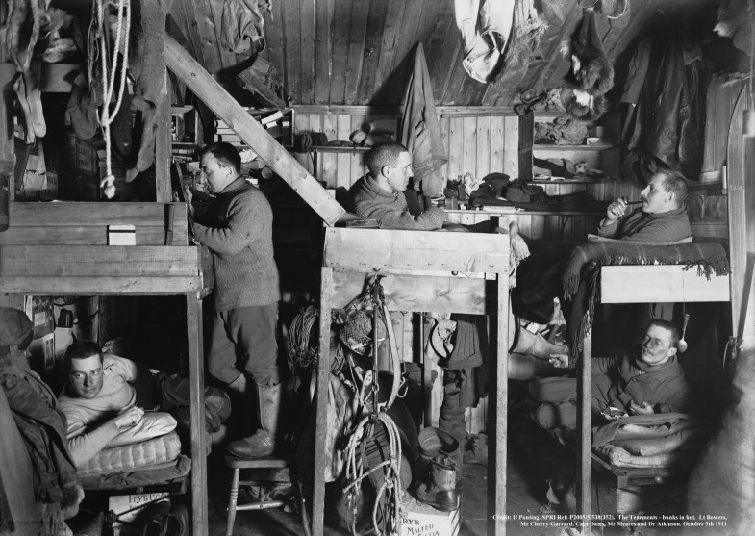  'Let's start early, before Scott,' Amundsen said. 'Remember, Scott has more men than us, and he has motor sledges, too. Perhaps they can go faster than us.'  ***  In Scott's camp, at Cape Evans, no one talked about Amundsen and no one worked hard. They had good food, and they played football on the snow. They wrote a newspaper - The South Polar Times - and read books. No one learnt to ski, no one worked on the motor sledges. Twice, men went for long journeys across the snow. They walked, and pulled the sledges themselves. Oates stayed at Cape Evans and looked after his ponies.  Over the window in Cape Evans, Scott put a map of Antarctica. With a pen, he made a line from Cape Evans to the South Pole, and he put a little British Flag at the Pole. Under the map, Scott wrote the day for the start of their journey.  We start on November 3rd, he wrote.  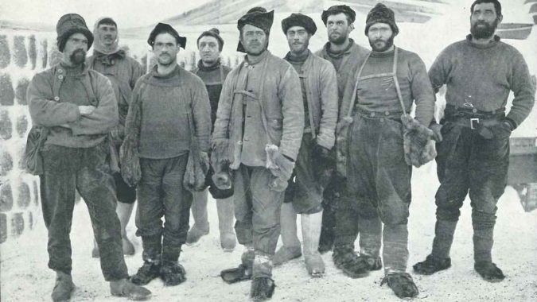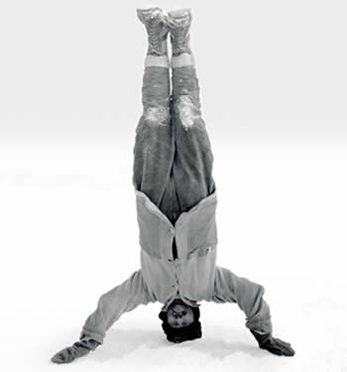  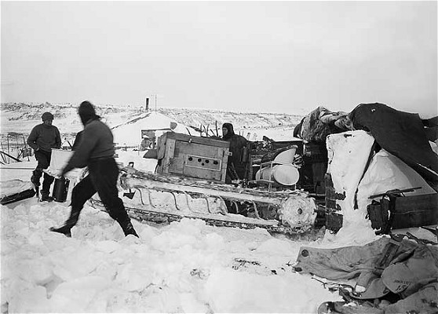 | 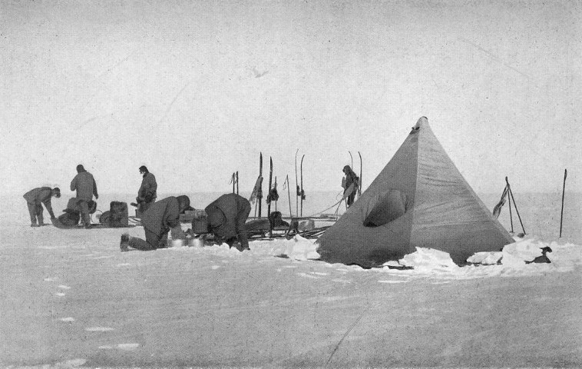  Bjaaland laughed. 'Oh no, they can't go faster than me,' he said. 'On snow, nothing can go faster than a good man on skis.'  'We don't know,' Amundsen said. 'You're the best skier in Norway, but you get tired, and dogs get tired, too. Motor sledges don't get tired. They can go all day and all night.'  Johansen laughed angrily. 'That's stupid,' he said. 'Perhaps the motor sledges can go all night, but the Englishmen can't. The English can't win, Roald - they don't understand snow, but we do. And they're too slow.'  'Perhaps,' Amundsen said. 'But I want to win this race. So we're going to start early! Do you understand?'  It was quiet and warm inside Framheim. Bjaaland looked at Amundsen, and thought about the long, cold journey in front of him. He thought about the dogs in their holes under the snow, and listened to the wind over the house. 'When, Roald?' he said quietly.  'On August 24th. The sun comes back on that day. We start then.'  'But we can't!' Johansen said. He looked angry, and unhappy. 'That's too early! We can't start then - it's dangerous and stupid!'  Amundsen looked at Johansen coldly. 'You're wrong, Johansen,' he said. 'We want to win, remember? So we start on August 24th.'  Bjaaland listened to the winter wind outside.  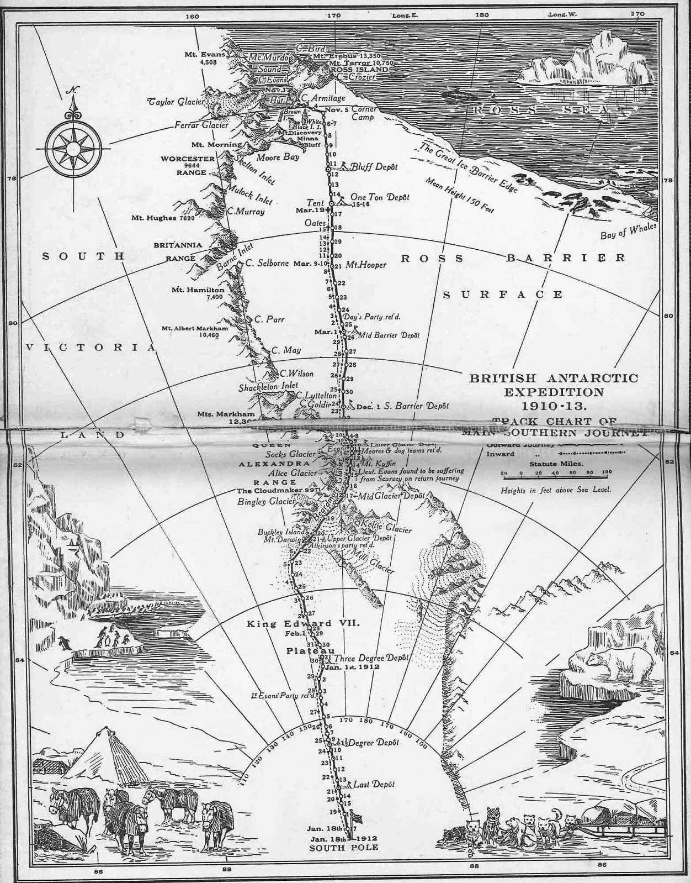

Chapter Five  A Long Cold Winter  1.Vocabulary:  Outside, dark, stay (stayed), change, strong – stronger, hard,  than before, equipment, think (thought, thought), journey, midwinter, early – earlier, perhaps, get tired, all day, all night, laugh (laughed), dangerous, stupid, learn (learnt, learnt), to ski,  2.Answer the Questions:  1)What was the Antarctic winter like?  2)What did Bjaaland do during the winter?  3)What did the Norwegians do?  4)What was Amundsen worried about?  5)What did he want to do?  6)When did Amundsen want to start his journey?  7)Did all agree with Amundsen’s plan?  8)Did Amundsen listen to his men? Why?  9)What did the British do in their camp?  10)What did Captain Scott put over the window?  3.Give the Beginnings to the Sentences:  1)________________________, it was often -60⁰ Centigrade.  2)_______________________ in warm holes under the snow.  3)________________ came from the best shops in Norway.  4)____________________________ on the skis and sledges.  5)_____________________ and worked on their equipment.  6)_______________________________ and talked about it.  7)_______________________________can go faster than us.  8)______________________________ and dogs get tired too.  9)____ and thought about the long, cold journey in front of him.  10)___ _____________and listened to the wind over the house.  11)____________________________ and no one worked hard.  12)___________________no one worked on the motor sledges. | 4.Insert the prepositions:  1)The men stayed ___ their house, and worked ___ their rooms _____ the snow.  2)The skis and sledges came ____ the best shops ____ Norway, but Bjaaland wasn’t happy ______ them.  3)He changed a lot __ things ___ the skis and sledges.  4)They looked ___ their dogs, and worked __ their equipment.  5)One day, ___ midwinter, he talked ___ his men.  6)’Let’s start early, _______ Scott’.  7)’___snow, nothing can go faster than a good man __ skis’.  8)The sun comes ______ on that day.  9)He thought _____ the dogs ___ their holes _____ the snow, and listened ___ the wind ____ the house.  10)______the map, Scott wrote the day ____ the start ___ their journey.  5.Match the Halves of the Sentences:  It was dark All the Norwegians The dogs lived The skis were better But I want It was quiet and warm worked hard. inside Framheim. to win the race. for four months. in warm holes under the snow. and faster, too.  6.SPEAKING:  Amundsen is speaking with his men about the race to the Pole.  7.WRITING:  Amundsen is writing in his diary about his doubts and dreams.  8.EXTENTIONS: Find out what the both teams did during the Antarctic winter. What books did they read? What games did they play?
CHAPTER SIX  A Bad Start  On August 23rd, the Norwegians' sledges were ready. They took them outside, and the dogs pulled them across the ice. The sun came up for a half an hour, but it was too cold: -46° Centigrade. They could not travel in that weather. They went back to Framheim and waited.  They waited two weeks, until September 8th. Then, with the temperature at -37° Centigrade, they started. They ran happily across the snow to the south - eight men, seven sledges, and eighty-six dogs. Only Lindstrem, the cook, stayed behind in Framheim.  At first everything went well. They went twenty-eight kilometres on Saturday, and twenty- eight kilometres on Sunday. It was easy.  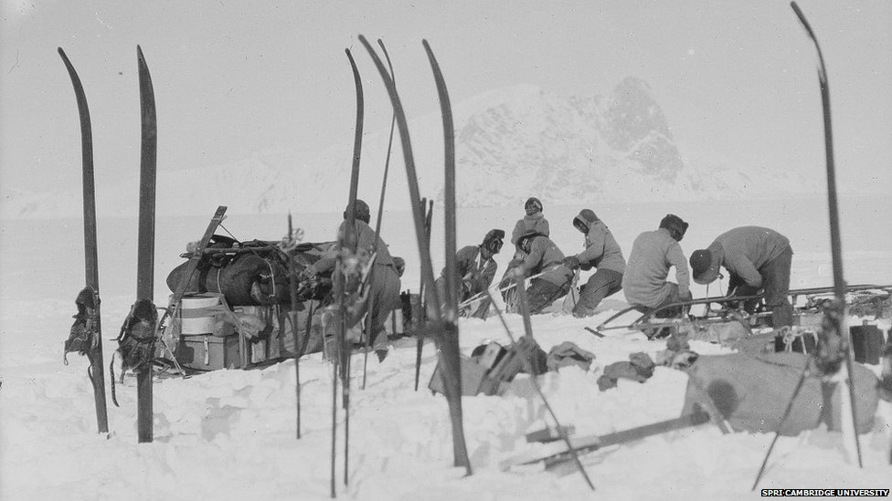  Then, on Monday, the temperature went down - to -56° Centigrade. There was white fog in front of their faces. They couldn't see anything. But they travelled twenty-eight kilometres.  That night, in their tents, they nearly died of cold. Next day, they stopped and made snow houses. Inside the snow houses, it was warm. But everyone was unhappy.  'I told you, Roald!' Johansen said. 'Even September is too early! We can't travel in this cold. Do you want us to die? Let's go back and wait for better weather.'  Amundsen was very angry. But at first he said nothing, because he knew that Johansen was right. Then, that evening, he gave a letter to Johansen. It said: “You aren't coming to the Pole with me. When I go south, you can take some dogs and go east to King Edward VII Land. You can go with Prestrud and Stubberud. You can be the first men to go there - but not to the South Pole!”  The Norwegians stayed in Framheim and waited. They lay in bed, listened to the wind outside, and thought about Scott and his motor sledges. CHAPTER SEVEN  Motor Sledges and Mountains  Scott had two motor sledges now. They were the first motor sledges in the Antarctic - the first on earth. On October 24th, the motor sledges started south from Cape Evans. Four men went with them, but Scott stayed at Cape Evans for another week.  Oates was unhappy. He wrote to his mother: ‘We had a very bad winter here. I don't like Scott. We were here all winter, but he didn't learn to ski, or to drive dogs. Our equipment is bad, and he doesn't think about other people. I'm going to sleep in his tent on the journey, but I don't want to’.  On November 1st Scott and Oates and six more men left Cape Evans with eight sledges and eight ponies. The ponies walked slowly because their feet went down into the snow. It was hard work for them and they got tired very quickly. They travelled thirteen or fourteen kilometres in a day.  Behind the ponies came Meares with one sledge and some dogs. Meares knew how to drive dogs. Every day, Meares started two hours after the ponies, and arrived two hours before them. After five days, they found the motor sledges.  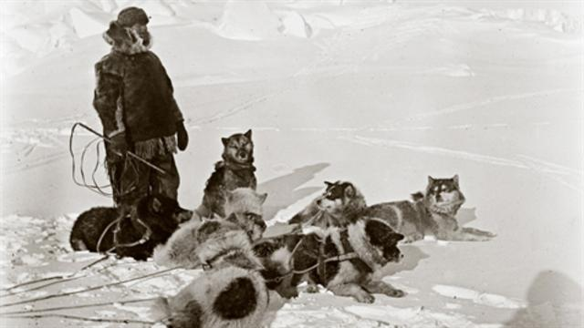  Oates looked at Meares. Oates and the ponies were tired, but Meares and his dogs were not. The snow was home for them.  That night, Oates wrote: ‘Three motor sledges at $1,000 each, 19 ponies at $5 each, 32 dogs at $1.50 each. Well, it's not my money, it's Scott's.  On November 21st, one of the ponies died.  ***  On November 11th, the Norwegians saw the mountains.  The mountains were very high - some of the highest on earth. Bjaaland smiled.  'There is good skiing up there, Roald,' he said. 'But can dogs get up there too?'  'Of course they can,' Amundsen said. 'Come on.'  They left Hanssen with the dogs, and skied a little way up the mountains. It was difficult, but the mountains were big and beautiful. Behind the mountains, Amundsen thought there was a high plateau of ice. 'That's it,' Amundsen said. 'That's the road to the Pole. Tomorrow, we can bring the dogs and sledges up here. But now, let's have a ski race. Who can get back to camp first?'  They laughed, and skied happily down the white snow. 'This is like home,' Bjaaland thought. 'But it's bigger than Norway, and better.'  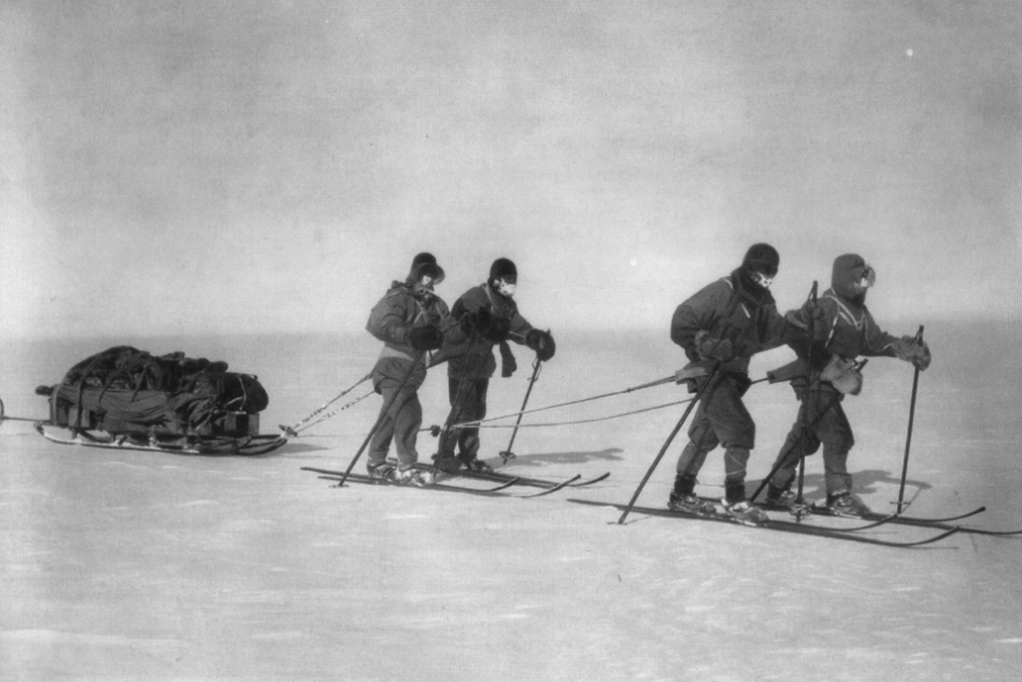 | Amundsen was very angry. He was angry with Johansen, but he was angry with himself, too. He knew Johansen was right.  'All right,' he said slowly. 'We can go on to the depot at 80° South, leave the food there, and then go back. We can't do more than that.'  It was thirty-seven kilometres to the depot. The wind was in their faces all day. Two dogs died on the way. At the depot, they did not stop. They put out the food and the flags, turned round, and went north.  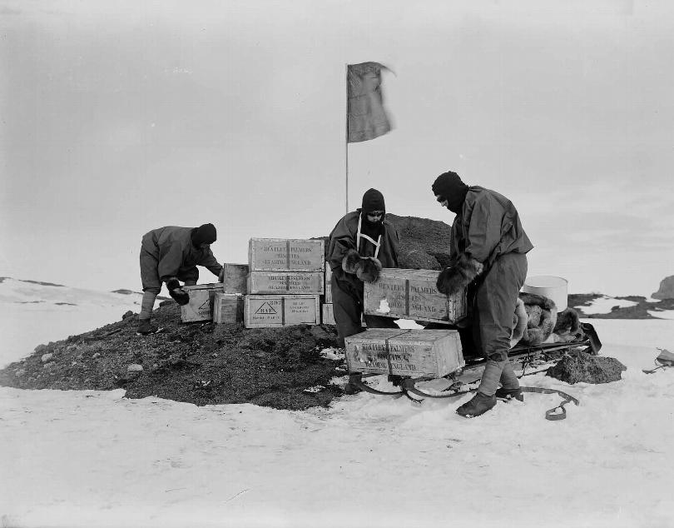  At last the wind was behind them. The dogs ran quickly, and the men sat on the empty sledges. They went faster and faster. It was like a race. Amundsen was on Wisting's sledge, and soon he, Wisting, and Hanssen were three or four kilometres in front. Soon they were alone. They travelled seventy-five kilometres in nine hours, and they reached Framheim at four o'clock that afternoon.  Bjaaland arrived two hours later, with two more men. But the last two - Johansen and Prestrud - went more slowly. Their dogs were tired, their feet were wet and cold, they had no food, and they were alone in the dark. The temperature was -51° Centigrade. They reached Framheim at midnight.  Next morning, Johansen was angry. In front of everyone, he said: 'You were wrong, Roald. September was too early. I told you but you didn't listen. And then you left us alone and we nearly died in the cold! You're a bad captain - I'm a better captain than you are!'  The Norwegians began again on October 20th. There were five men this time - Amundsen, Bjaaland, Wisting, Hassel, and Hanssen. They had four sledges, and forty-eight dogs.  There was a lot of wind and fog. On the first day, Wisting's sledge suddenly stopped, and the back went down. 'Come on, you dogs!' he said angrily. 'Pull! Pull!' At first nothing happened; then, slowly, the sledge moved again. Wisting looked down, over the side of the sledge. Under the snow, there was a fifty metre hole.  'Did you see that?' Amundsen said. 'The ice wants to eat us - men, dogs, sledges, everything.'  On the fourth day they reached the depot at 80° South. There was a bad snowstorm, but they found the flags easily. Next day the men stayed in their tents, and the dogs played in their holes under the snow. They were all happy. They had a lot of food, they had good equipment, and they were warm. They could travel fast.  Next morning, the snowstorm stopped, and the journey began again. Today, everything is wonderful, Bjaaland wrote in his diary. But where is Scott? In front of us, or behind?  There was no one with the motor sledges; they were broken. Scott looked at them angrily.  'It doesn't matter,' he said. 'Teddy Evans and his men are in front of us. They're good men - they're pulling their sledges themselves. We can get to the Pole on foot.'  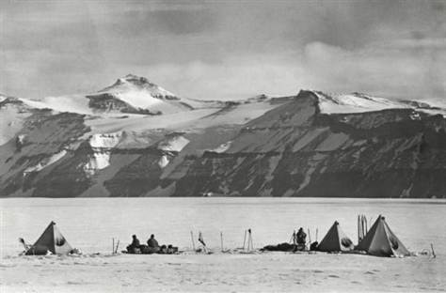  In the next four days, the dogs pulled the sledges eighty-one kilometres, and went up 3,000 metres. At last, Amundsen and Bjaaland stood on the plateau behind the mountains. They were tired, happy men.  Bjaaland looked back at the mountains. 'Can a motor sledge get up here?' he asked.  Amundsen smiled. 'No,' he said. 'I don't think so. And Scott doesn't like dogs. So his men are going to pull their sledges up these mountains themselves. Would you like to do that, Olav?'  Bjaaland didn't answer. He smiled, and skied happily away across the snow.  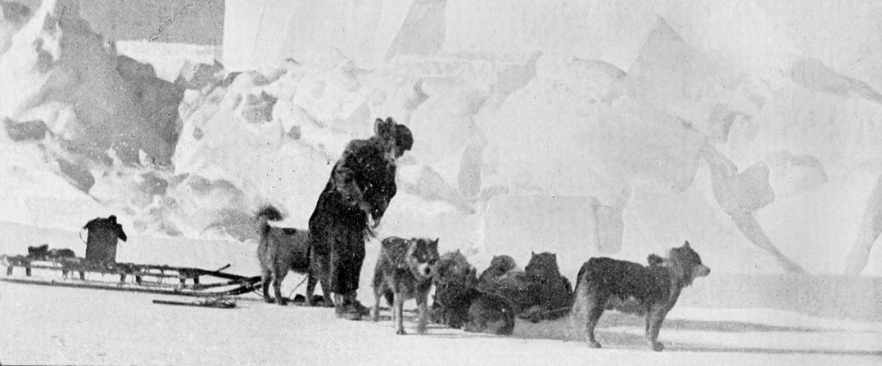  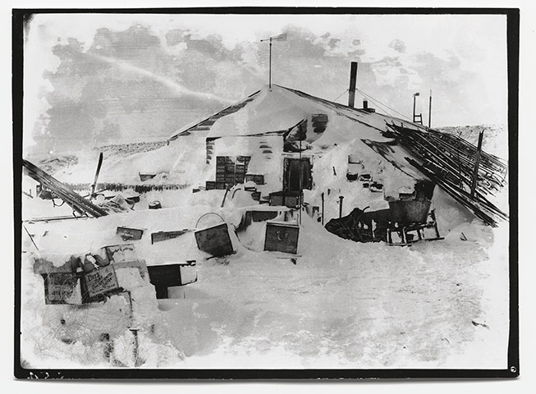
Chapter Six  A Bad Start  1.Vocabulary:  Outside, inside, can (could), push, pull, temperature, stay behind, go down, fog, even, be angry with, alone, reach, nearly, die (died, died)  2.Answer the Questions:  1)When did the Norwegians start? What was the weather like?  2)How cold was at night? How did they manage?  3)What did Amundsen decide to do? How many men travelled?  4)Why was it difficult for them to travel?  5)Did all the Norwegians return to Framheim?  6)Why was Johansen angry?  7)How did Amundsen feel?  8)What did Amundsen give Johansen that evening?  9)What did the Norwegians think laying in their beds that night?  3.Insert the Missing words:  1)On August 23rd, the Norwegians’ _______ were ready.  2)The sun came up ____ ___ ___ __ ___ but it was too cold.  3)They could not travel in that _______.  4)They ran happily ________ the snow to the __________.  5)At first _____________ went well.  6)Then, on Monday, the temperature _________ ________.  7)There was white ________ in front of their ________.  8)They couldn’t see ____________.  9)That night in their ______ they nearly _______ of cold.  10)Next day they stopped and made ______ ___________.  11)’Do you want us to _______?  12)Amundsen was ______ _______ Johansen.  13)He was __________ _______ himself, too. | 4.Match the Two halves of the Sentences.  1.Let’s go back and wait 2.He knew Johansen 3.We can’t do more 4.The wind was in their faces 5.It was thirty-seven 6.Two dogs died 7.They put out a)was right b)kilometres to the depot. c)all day. d)for better weather. e)than that. f)the food and the flags. g)on the way.  5.Insert the Prepositions:  1)They could not travel ___ that weather.  2)___ the depot they didn’t stop.  3)At last the wind was ________ them.  4)They reached Framheim ___ four o’clock that afternoon.  5)They were alone ______ the dark.  6)And then you left us alone and we nearly died ___ the cold!  7)’You aren’t coming __ the Pole ___ me’.  6.Make Degrees of Comparison to these Adjectives:  Slow - _________, _____________ cold- ________, ________  Fast - __________, ____________ wet - _______, _________  Late - __________, ____________ good- _______, _________  Happy - ________, _____________ angry _ ______, _________  7.WRITING: a)Johansen is writing in his diary about their trip on September, 8th.  b) Amundsen is writing in his diary about his thoughts and plans and about their bad luck.  8.SPEAKING: Amundsen is speaking with his men about the trip to the south pole.  9.EXTENTIONS: Find facts about the North Pole and South Pole: temperature, animal life, and compare.
Chapter Seven  Motor Sledges and Mountains  1.Vocabulary:  Sledges, on earth, Cape Evans, learn to ski, learn to drive dogs, equipment, journey, slowly, get tired, arrive, hole, snowstorm, pulled the sledge themselves, on foot, mountains, high plateau, road, laugh (laughed, laughed),  2.Answer the Questions:  1)What equipment did Scott and his men have?  2)Why was Oates unhappy?  3)Why couldn’t ponies walk quickly?  4)When did the Norwegians start the race?  5)What happened to one of the sledges? What did Wisting see?  6)What happened to the Norwegians at the 80⁰ Depot?  7)What happened to the motor sledges?  8)How did Scott decide to get to the south pole?  9)Why did the Norwegians feel happy at the plateau?  10)What did Amundsen understand?  3.True or False?  1)Motor sledges were widely used for travelling.  2)Oates was unhappy because he missed his mother.  3)Scott’s men didn’t know how to drive dogs.  4)One Norwegian sledge got down into the hole.  5)The Norwegians were caught in the snowstorm at 80⁰ South.  6)Scott decided to get to the south pole on foot.  7)It was easy for the Norwegians to go up the mountains.  8)The mountains in the Antarctic are very high.  9)It was very difficult for Scott and his men to go to the South.  10) | 4. Insert the Missing Words:  1)The ponies walked ___________ because their feet went ______ into the snow.  2)Every day Mearses started two hours _______ the ponies and arrived two hours _______ them.  3)There was a lot of ______ and ______.  4)At first nothing___________; then, slowly, the sledge ______ again.  5)Under the snow there was a fifty metre ______ .  6)The ice wanted to ______ us.  7)Next day the men _____ in their tents, and the dogs played in their _______.  8)We can get to the pole ___ ______.  9)On November 11th, the Norwegians saw the ___________.  10)Behind the mountains, Amundsen thought there was a _______ _________ of ice.  11)That’s the _______ to the Pole.  12)They laughed and ________ happily down the white snow.  5.Explain in your own words:  Equipment - _________ Ponies - __________  Sledge - __________ Snowstorm - ________  Camp -_______________ Plateau - _____________  6.WRITING:  a)Oates writes to his mother about hardships of their expeditions.  b)Amundsen writes about their trip to the mountains and the plateau.

CHAPTER EIGHT  Across the Plateau  On November 21st, the Norwegians killed thirty dogs.  'They were happy,' Amundsen said. 'And now they're going to die quickly. We need three sledges, and eighteen dogs, to go to the Pole.'  When the dogs were dead, the other dogs ate them. The men ate them, too. They were good friends, Bjaaland wrote in his diary. And now they are good food. Two days later, the dogs were fat. Then, in a snowstorm, they began the journey again.  After the snowstorm, there was fog, and in the fog, they got lost on an ice river with hundreds of big holes in it. They could see nothing, and it was very dangerous. In four days they moved nine kilometres. But the ice is beautiful, Bjaaland wrote. Blue and green and white. This is a wonderful place but I don't want to stay a long time.  After the ice, there were strong winds and bad snowstorms. They could see nothing in front of them. But every day, they travelled twenty-five or thirty kilometres. Then, on December 9th, the sun came out. They were at 88° 23' South - 175 kilometres from the Pole.  Five more long days, Bjaaland wrote. That's all now. But where is Scott?  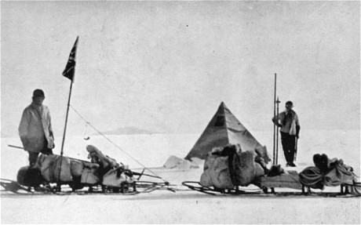  ***  December 14th 1911 was a warm, sunny day. Five Norwegians skied over the beautiful white snow. It was very quiet. No one spoke. They were excited, and happy.  'Six more kilometres,' Bjaaland thought. Is there a British flag? I can't see a flag, but... '  'Look!' Hassel said. 'What's that over there?'  Bjaaland left his sledge and skied quickly away over the snow. 'What is it?' he thought. 'Is it. . .?No!'  'It's nothing!' he called. 'There's nothing there . . . nothing!'  Three kilometres, two. 'Roald!' Hanssen called to Amundsen. 'Go in front of me, please. It helps my dogs.'  'That's not true,' Bjaaland thought. 'His dogs are running well today. But Hanssen wants Amundsen to be first. The first man at the South Pole!'  They skied on and on, over the beautiful snow.  'Stop!' Amundsen said. He waited quietly for his men. 'This is it,' he said.  Bjaaland looked at him. 'But there's nothing here,' he said.  Amundsen smiled. 'Oh yes there is,' he said. 'There's something very important here, Olav. Very, very important.' 'What's that, Roald?' there, with a Norwegian flag on it.  'Us. We're here now. Isn't that important, Olav?' The four men stood on the snow, and looked at him. Then, slowly, they all began to laugh.  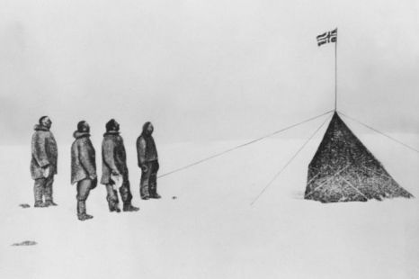 | ***  For four days, Scott's men stayed in their tents near the mountains. There is a bad snowstorm outside, Oates wrote. It's too cold for the ponies, and our clothes and skis are bad, too.  On December 9th, Oates killed the ponies. They were tired and ill and they could not walk up to the plateau. Then Meares and his dogs went back to Cape Evans. 'We can pull the sledges ourselves,' Scott said. 'We can do it - we're all strong men.'  There were two sledges and eight men. They went twenty- four kilometres a day. On December 31st, Scott said to Teddy Evans, and the men on the second sledge: 'You can't ski well.  'Leave your skis here.' So they pulled their sledge twenty-four kilometres without skis.  Next day, Scott went to Teddy Evans's tent. 'You are ill, Teddy,' he said. 'You can't come to the Pole. Take two men and go back, tomorrow.'  Teddy Evans was very unhappy. 'Two men, Captain?' he said. 'Why not three?'  'Because Bowers is going to come with me,' Scott said. 'He's strong - we need him.'  'But... you have food on your sledge for four men, not five!' Evans said. 'And Bowers has no skis!'  'I'm the Captain, Teddy!' Scott said. 'You do what I say. Take two men and leave Bowers with me!'  Oates wrote to his mother: I am going to the Pole with Scott, I am pleased and I feel strong. But in his diary he wrote: My feet are very bad. They are always wet now, and they don't look good.  On January 4th Scott's men left Teddy Evans and went on. Scott, Oates, Wilson and Edgar Evans had skis, but Bowers did not. They were 270 kilometres from the Pole.  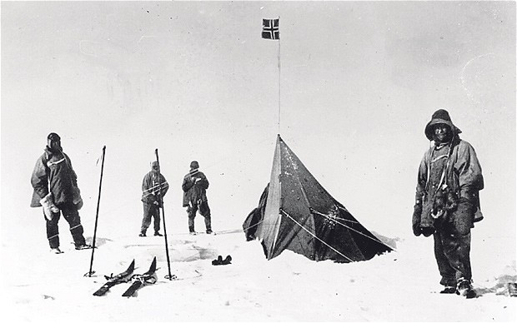  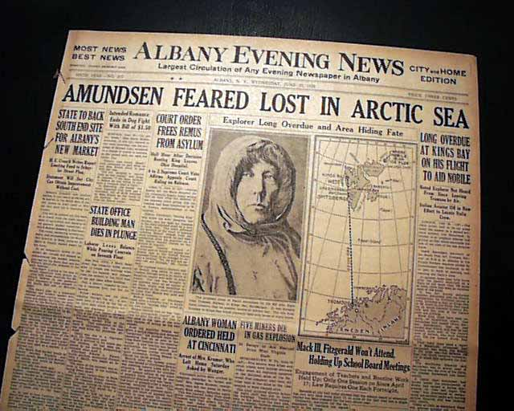

Chapter Eight  Across the Plateau  1.Vocabulary:  Plateau, fog, ice river, hundreds, holes, dangerous, snowstorm, at 88⁰ 23' South, ski, leave (left, left), quiet, excited, over there, important, enough,  2.Answer the Questions:  1)Where did the Norwegians get meat?  2)Why was it dangerous after the snowstorm?  3)What was the weather like on their way to the South pole on December 9th?  4)What did Scott and his men do on December 9th?  5)Why did they leave their skis?  6)Why was Teddy Evans unhappy?  7)Was there enough food for all the men in Scott’s team?  8)What was the problem with Oates’ feet?  9)What was the weather like on December 14th 1911? What is that day known for?  10)Why did Hanssen let Amundsen go in front of him?  11) What were the feelings of the Norwegians?  3.Find Synonyms to the Words:  begin - ____________ fog - __________  snowstorm - __________ dangerous - ___________  exhausted - ___________ return - _________ _______  fast - _________________ not one thing _____________  4.Insert the Missing words:  1)After the snowstorm there was ______, they got ______ on the ice river with hundreds of big _______ in it.  2)They could see nothing, and it was very ________________.  3)After the ice there were strong ______ and bad __________ . | 4)But every day they travelled ________ or _______ kilometres.  5)_______ Norwegians skied over the beautiful white snow.  6)They were __________ and happy.  7)Hanssen wants Amundsen to be _________.  8)The first man on the _________ _________.  5.Match the Two parts of the Sentences:  1.For four days, Scott’s men 2.It was too cold 3.We can pull the sledges 4.We can do it – 5.Take two men 6.But… you have food on your sledge 7)I am the Captain, 8)My feet are 9.They are very wet now, and a)for four men, not five! b) and go back. c)we are all strong men. d)ourselves. e) for the ponies. f)stayed in their tents near the mountains. g)they don’t look good. h)You do what I say. i)very bad.  6.WRITING:  a) you are a journalist, and you are going with Amundsen to the South Pole. Describe how you reached it.  b)Captain Robert Scott writes in his diary about their travel to the South Pole.  7.SPEAKING: Roald Amundsen speaks in front of the members of the Geographical Society about his Discovery of the South Pole.  8.EXTENTION: Find the information about Amundsen’s approaching the South Pole.
CHAPTER NINE  The End of the Race  The Norwegians stayed two days at the Pole. They left a tent there, with a Norwegian flag on it. Inside the tent, they left some food, a letter for the King of Norway, and a letter for Scott.  They left some more black flags near the Pole, and one twenty-eight kilometres north. Then they skied away, back to the north.  'It's a beautiful day,' Bjaaland wrote. 'The sun is warm, the snow is good. But the dogs run too quickly – I cannot get in front of them!'  They found their depots easily. There were ten between the Pole and Framheim. Each depot had a lot of food. They laughed and skied quickly down the mountains. Often, they skied fifty kilometres a day. On Friday, January 26th, 1912, they came back to Framheim. It was four o'clock in the morning.  Inside the wooden house, Lindstrem, the cook, was asleep. Amundsen walked quietly to his bed. 'Good morning, Lindstrom,' he said. 'Is our coffee ready?'  ***  The black flags waited at the Pole.  'What's that, Captain?' Bowers said. 'Over there?'  'Where?' Scott asked. 'What - oh my God!'  They all saw the small black flag in the snow, two kilometres in front of them. Slowly, they pulled their sledge to it.  Next day, January 17th 1912, they found the tent and the Norwegian flag. Near it, Scott took the British flag from under his clothes, and put it up. In his diary, Scott wrote: This is a very bad day. We are all tired, and have cold feet and hands. It is -30°  Centigrade and there is a snowstorm. Great God! This is an awful place!  They turned north. Five tired, unhappy men, in the coldest, emptiest place on earth.  'What's the matter?' her friend asked.  'My poor, poor husband,' Mrs Scott said. 'What's happened to him? Where is he now?'  *** Scott's men were always hungry. There were not many depots and they were difficult to find. We need to find the next depot today, Oates wrote. But how can we find one black flag in all this snow? It's very difficult. And there is food for four men, not five.  They were all tired and ill, too. Oates's feet were black now, and he could not feel them. On February 16th, Edgar Evans died.  On the 17th they were past the mountains. At the depot there they ate one of the dead ponies. Then they went on - ten, eleven, twelve kilometres a day. They were ill because their clothes were not warm and they didn't have much food. The temperature was sometimes ----- 40° Centigrade.  On March 7th Scott looked at Oates's feet. They were big and black. 'I can't pull the sledge now,' Oates said. 'It's very difficult to walk. Am I going to lose these feet, Captain?'  Scott looked at Oates's feet, and said nothing.  On March 9th they found another depot, but there was not much food. Slowly, they walked on. Oates's feet were worse every day.  March 17th was Oates's birthday. He was thirty-two. He lay in the tent and listened to the wind outside. He was very cold, very hungry, and very very tired.  He wrote a letter to his mother and gave it to Wilson. Then he got up, and opened the door of the tent. He stopped in the door for a minute. Scott, Wilson, and Bowers looked at him. They didn't speak.  'I'm going outside for a minute,' Oates said. 'I may be some time.'  They didn't see him again.  At Cape Evans, the Englishmen waited. On December 11th, Meares and the dogs came back. On January 3rd, Teddy Evans and his two men arrived at Cape Evans. The Terra Nova came, and went. Winter began. Scott did not come. | 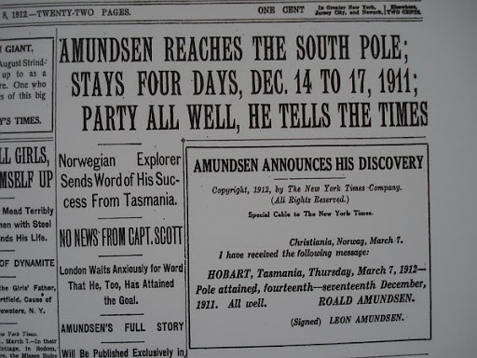  On March 13th, 1912, Scott's wife Kathleen, looked at her morning newspaper. NORWAY'S FLAG AT SOUTH POLE, it said. She looked at it for a long time, and then began to cry.  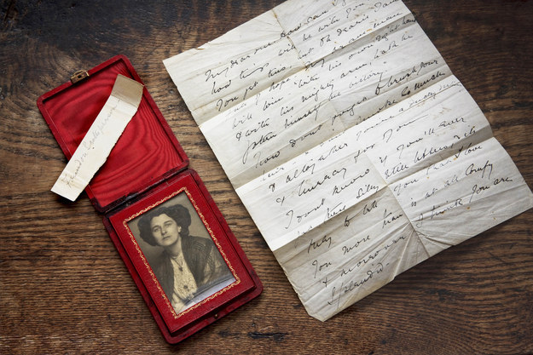  The Englishmen waited all winter at Cape Evans. Then, on October 26th 1912, they started for the south. Two weeks later, they found a tent. There were three bodies in the tent - Scott, Wilson, and Bowers. They put the bodies under the snow. Then they took the men's letters and diaries, and went north to Cape Evans again.  In Scott's diary they read: Oates died like a good Englishman. We all did. Please, remember us, and look after our families. We did our best.  No one found Oates's body. But he is there, somewhere, under the snow and the wind, in the coldest, emptiest place on earth.  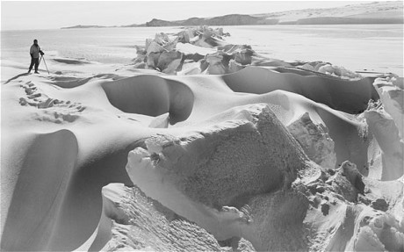  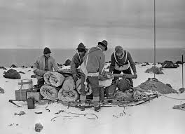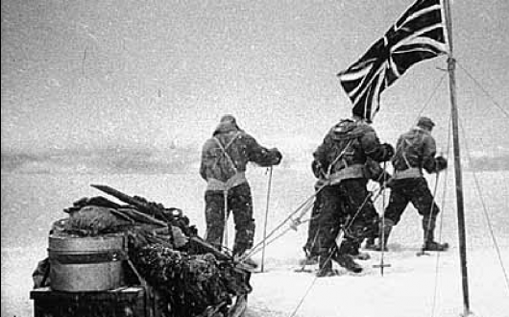

Chapter Nine  The End of the Race  1.Vocabulary:  Stay, leave (left, left), tent, King, outside, be tired,  2.Answer the Questions:  1)What did the Norwegians make at the south pole?  2)How many depots did they have between the Pole and Framheim?  3)How many kilometres did they ski a day?  4)How long were they away from Framheim?  5)What did Amundsen ask from their cook when they returned?  6)What did Scott see first on January 16th 1912?  7)Why did Scott’s wife cry?  8)Why was it difficult for Scott’s men to find their food depots?  9)What happened to Oates’ feet?  10)What did Oates do on his birthday?  11)How long did the Englishmen wait for the expedition?  12) What did they find in the tent?  13) What were Scott’s last words?  3)Insert the Prepositions:  1)The Norwegians stayed two days _____ the Pole.  2)________ the tent they left some food, a letter ___ the King of Norway, and a letter ___ Scott.  3)But the dogs run too quickly – I cannot get _ ____ ___ them.  4)There were ten depots _______ the Pole and Framheim.  5)They laughed and skied quickly _____ the mountains.  6)On Friday, January 26th, 1912they came ____ __ Framheim.  7)______ the wooden house, Lindstrem, the cook, was asleep.  8)Amundsen walked quietly ____ his bed. | 4.Finish the Sentences:  1)The black flags _____ ___ ___ _______.  2)They all saw ________________________________.  3)Slowly they _____________ ______ _____________.  4)Next day, January 17th, 1912, _____________________.  5)Near it, Scott took the British flag___________________.  6)They turned North. Five tired, unhappy men, ___________.  7)Scott’s men ________________.  8)But how can we find one black flag_________________?  9)And there is food for______________________.  10)They were ill because__________________________.  11)The temperature was sometimes________________.  12)On March 9th, they found another depot, but ____________.  13)He lay in the tent and listened to________________.  14) he wrote a letter to ____________________________.  15)Then he got up, and opened ______________________.  16)The Englishmen waited __________________________.  17)Then, on October 26th, 1912, they started ___________.  5.WRITING:  You are a journalist and a member of a rescue party. You describe what you saw and your feelings.  6.SPEAKING:  a)Speak about Amundsen’s expedition, how they reached the South Pole and returned back to their base camp.  b)Speak about Scott’s expedition, how they got to the South Pole and what happened to them on their way back.  6.EXTENTIONS: Find information about Robert Scott’s diary.  Find out about Titus Oates’ life before he joined Scott’s expedition.
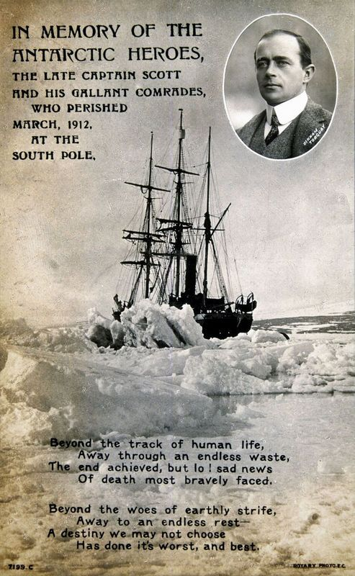 | 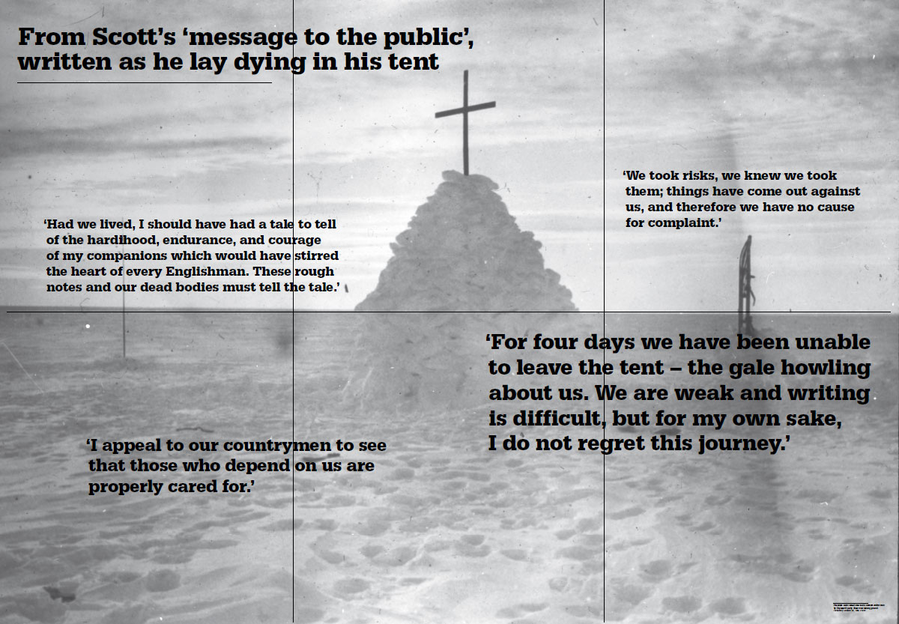  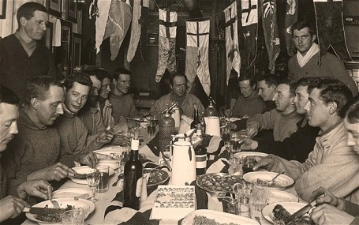
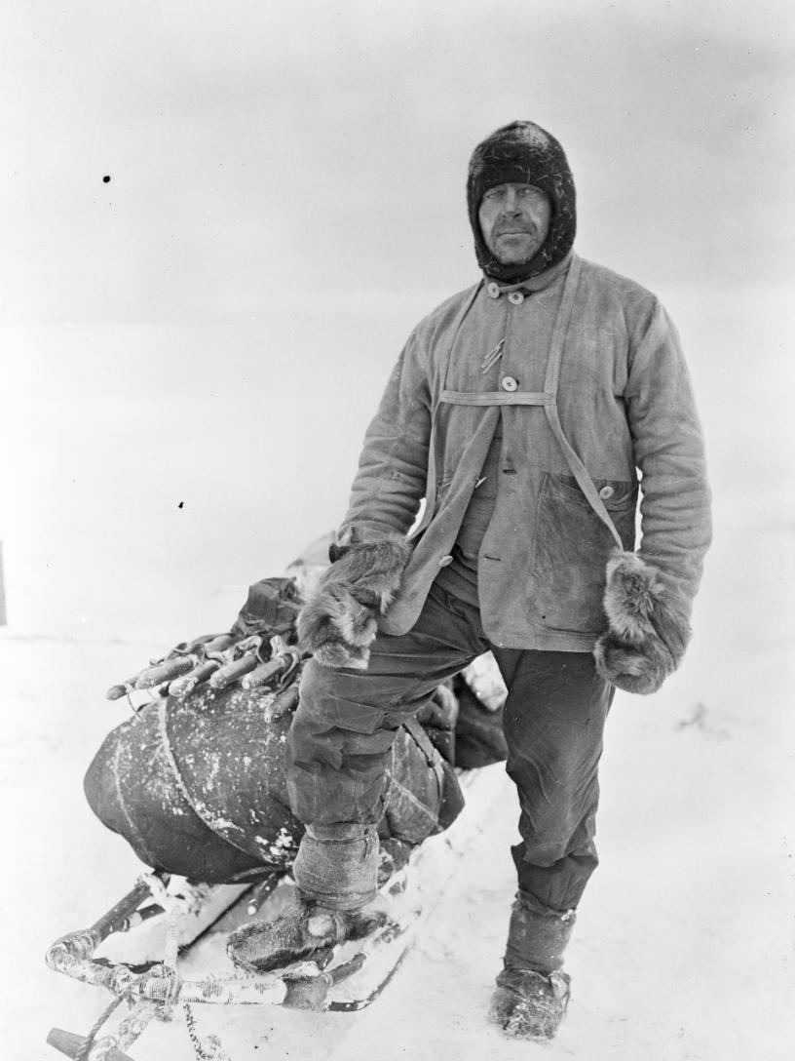
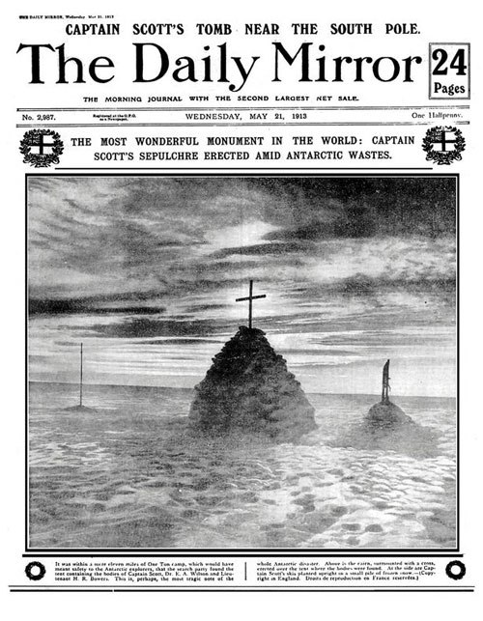
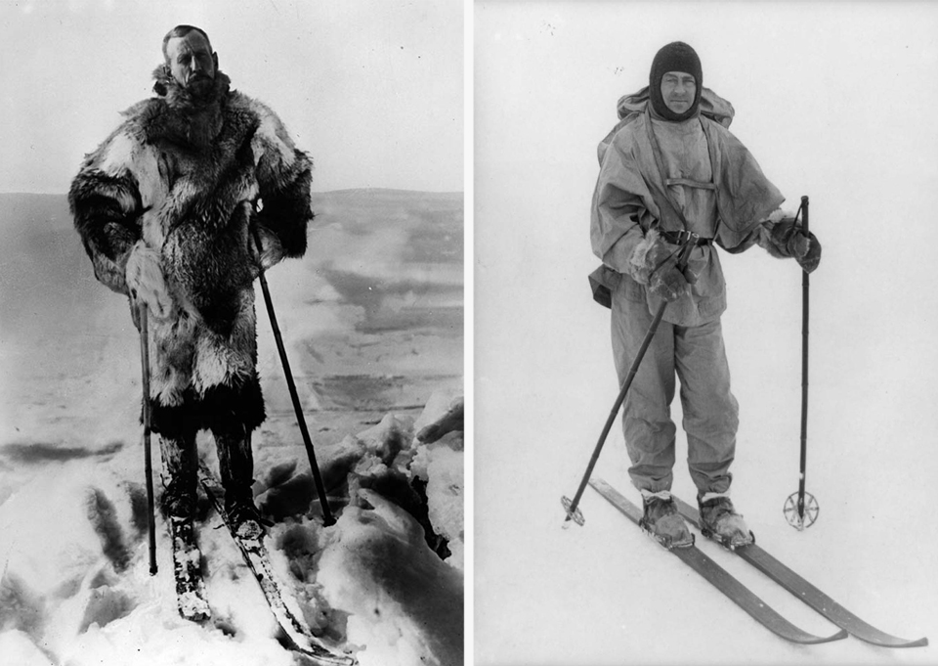

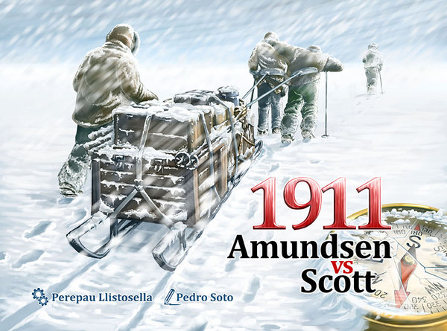
The Coldest Place on Earth

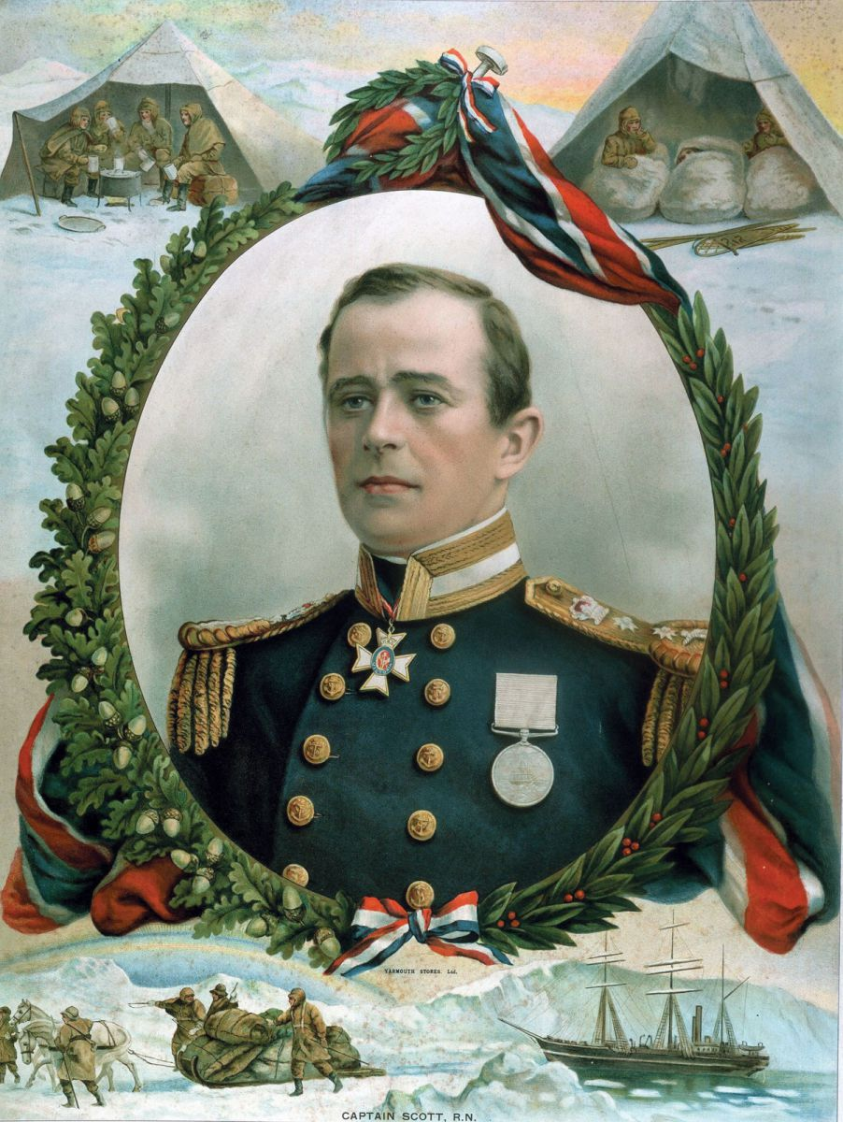
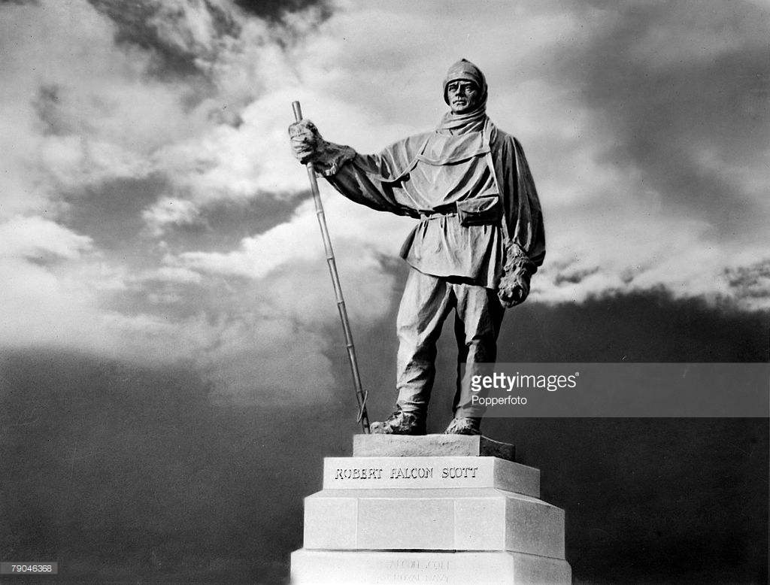
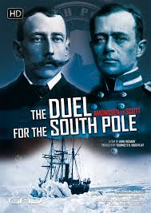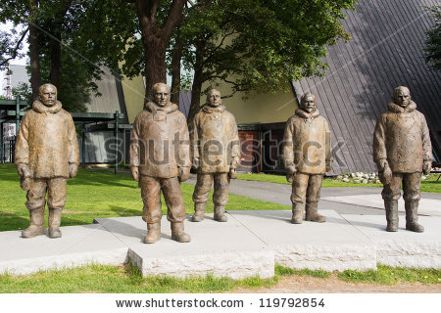

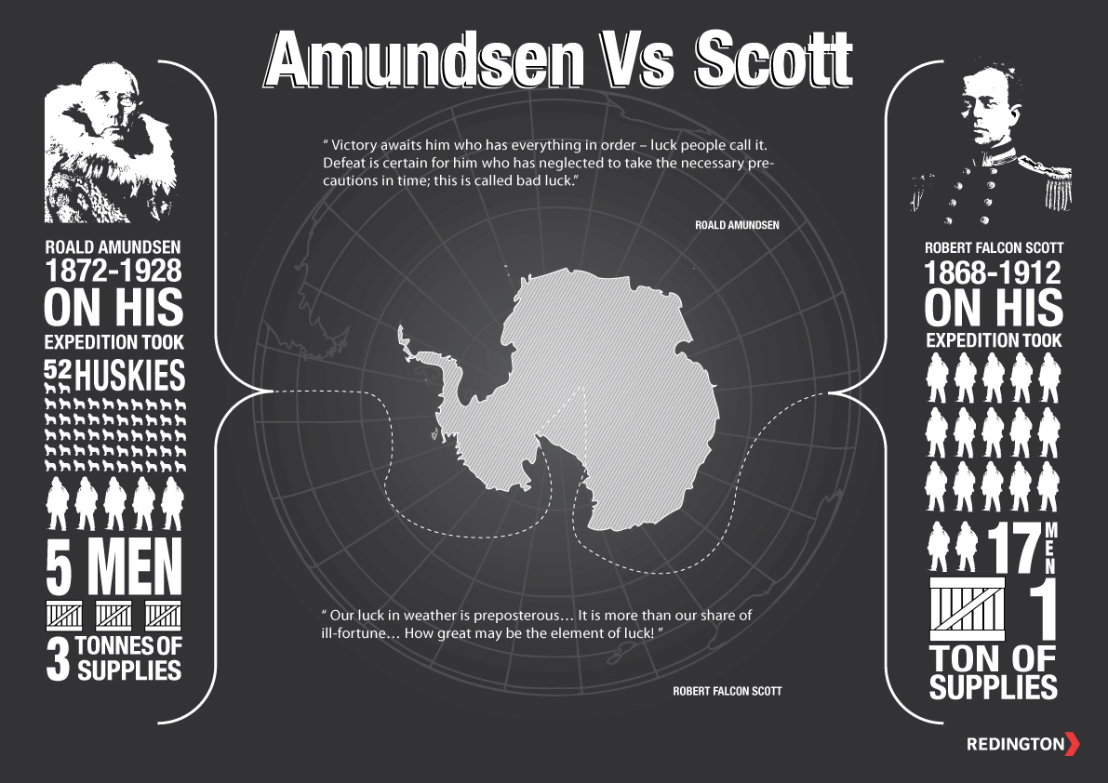

Chapter Four  Food Depots  1.Vocabulary:  Depot, pull, sledges, to run on skis, outside, holes, journey, leave (left, left), need, carry (carried), half a tonne, Centigrade, Celsius, reach, hard – harder, be tired, nearly, far away, alone, preparation, expedition, the following year, the total darkness- the Polar winter, wait impatiently, signs of spring, slow-slower,  2.Answer the Questions:  1)When did the two ships arrive in the Antarctica?  2)What were the both teams planning to do in Antarctic winter?  3)What did the Norwegians build on the ice?  4)What did the Norwegians want to make on their way to the South?  5)Where did they make their first depot?  6)How did they make their depots?  7)How did the Scott’s team move to the South?  8)Why didn’t Scott want to kill the ponies?  8)What happened to the ponies and the moto sledge?  3.Give a Words to the Definition:  500 kilogrammes _______________  To go from the place _______________  To go to some place _______________  To be not near _______________  Next year __________________  A store __________________  A journey ________________  Getting ready ___________________  Cannot wait until ________________  Almost ______________ | 4.Find the Opposites:  to stay - ______________ to drop - _______________  light - ________________ to push - _______________  easy - ________________ fast - __________________  together - ____________ very close - _____________  5.Insert the Missing Words:  1)The Englishmen and the Norwegians wanted to _______ on the ice all __________.  2)The dogs ____________ the big sledges from the ship onto the ice.  3)They put a big _________ ______ on the ice.  4)When the house was ready, the men made their first _____ south.  5)Before the ______ they wanted to take a lot of food _______, and leave it in ____________.  6)The ______ was good, and the ______ and _____ went fast.  7)They went _____ or _____ kilometres every day.  8)Then they went _____ to Framheim, and took some more _____ south, this time to 82⁰ ________.  9)Oates went with Scott to make the first British _______.  10)The ______ were faster than ________.  11)At night the dogs made warm ______ under the snow.  6.SPEAKING:  a)Amundsen speaks how he made his depots.  b)Scott speaks how he made his depots.  7.WRITING:  Oates writes in his diary about the situations with the ponies.  8.EXTENTIONS:Find out what food did both teams ate and stored in their depots.
Ch.4 6.SPEAKING:  a)Amundsen speaks how he made his depots:  When we came to Antarctica it was the Antarctic summer, and we understood that we had to hurry before winter came. We wanted to be ready to go to the South Pole at the beginning of the next Antarctic summer. To begin with, we put a big wooden house on the ice. We took a lot of food and equipment from the ship and put it all into the house. We called this house Framheim. Before the winter we wanted to take a lot of food south, and leave it in Depots. It was not very cold – 17 ⁰ Centigrade. When we reached 80⁰ South we made our first depot. We made it very carefully. It was very important to find it again next summer. So we put a big black flag on top. Then we put ten flags to the east of the depot – each flag half a kilometre from the next, and ten flags to the west. So there were flags for five kilometres to the left of the depot, and five kilometres to the right.  Then we went back to Framheim, and took some more food with us and went this time to 82⁰ South. This time it was harder. The temperature was sometimes -40⁰ Centigrade, and there were strong winds with a lot of snow. The dogs and the men were very tired. But we made our second depot and we put out 60 flags, to help us find this depot again next summer.  We came back to Framheim on March,23rd . It was nearly winter in the Antarctic. Our ship the Fram was far away now, near South America, and we were alone on the ice till next summer. | b)Scott speaks how he made his depots.  It was January 25th we left Cape Evans to the south to make our first depot. There were thirteen men, eight ponies, and twenty-six dogs. The dogs were faster than the ponies - they ran quickly over the top of the snow, but the ponies' feet went through it. Every morning the ponies started first, and the dogs started two hours later, because they ran faster. At night, the dogs made warm holes under the snow, but the ponies stood on top of the snow. It was -20° Centigrade.  It took us twenty-four days to get to 80° South. We made a big depot there, and put one large black flag on top of it. Then we went back to Cape Evans.  7.WRITING: Oates writes in his diary about the situations with the ponies.  February 14th. Antarctic is a very dangerous place. The weather is very bad: very cold with snowstorms and blizzards. The dogs made warm holes under the snow and lived there. But the ponies stood on top of the snow and soon one by one the ponies got ill. They couldn’t go on. I asked the Captain to kill three ill ponies and leave the meat in the depot, in the snow. We can eat it, or the dogs can. But Captain Scott said angrily that he didn’t kill or eat his friends. And so three days later two of the ponies were dead. And then another disaster: our camp was on an island in the ice, and the ice moved sometimes. There were holes in the ice, and the black sea water under it. One day seven ponies went through the ice into the sea and died. One motor sledge also went into the sea.

